Prometheus and Grafana
Task 1 — Install Prometheus on AWS EC2 (Amazon Linux 2023)
We'll use a new Amazon Linux 2023 EC2 instance, your existing jenkins.pem key pair, the default VPC, and the default security group, as requested.
We'll set up the server first, install Prometheus, configure prometheus.yml, and verify that Prometheus is running before moving to Node Exporter.
Step 1 — Launch the EC2 instance
Open the AWS Console: EC2 Dashboard
1. Name the instance
Enter prometheus-monitoring-server as the instance name.
2. Select the AMI
Choose Amazon Linux 2023 AMI (64-bit x86)
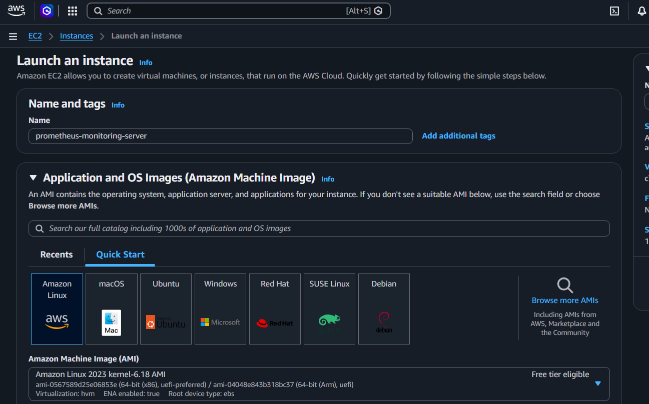
3. Select instance type
Use t3.medium (2 vCPU, 4 GiB RAM) for this lab, especially when running all monitoring components on one machine. Check your AWS pricing and Free Tier eligibility first.
4. Select the key pair
Choose the existing jenkins key pair. Do not create a new key pair if jenkins.pem is already available locally. 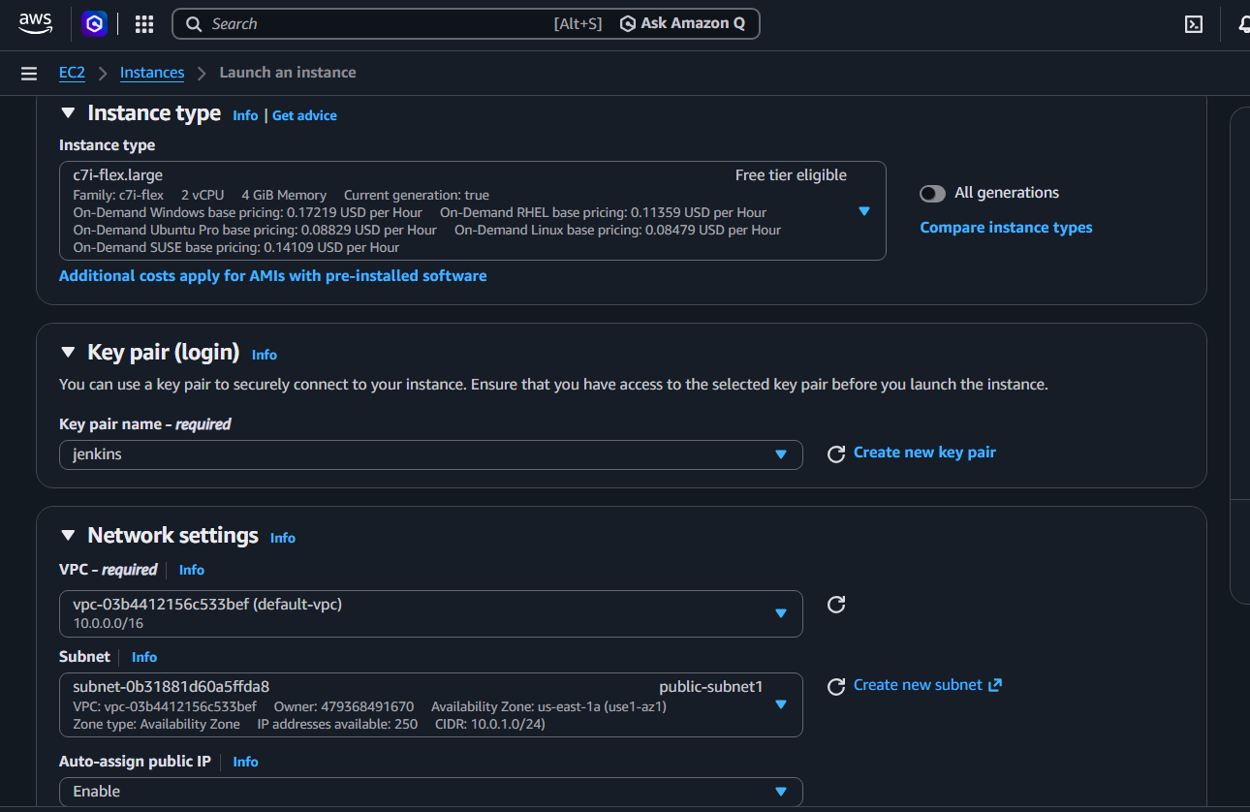
Step 2 — Configure networking and storage
In the EC2 launch page, set the following:
Setting | Value
VPC | Default VPC
Subnet | Default subnet
Auto-assign public IP | Enable
Security group | Select existing default security group
Key pair | jenkins
Root storage | 20 GiB gp3
Important security-group detail: the VPC's default security group normally does not allow inbound SSH from your computer. Add an SSH inbound rule to the existing default security group if needed. AWS recommends restricting SSH to your own public IP rather than allowing everyone.
 Amazon Elastic Compute Cloud +2
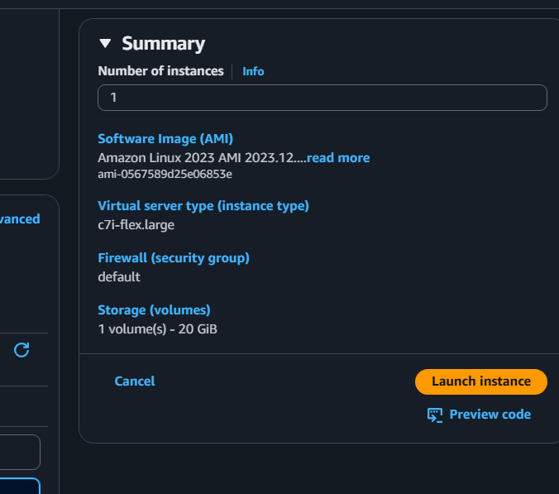
For the first stage, use this inbound rule:
Type | Port | Source
SSH | 22 | My IP
We will access Prometheus and Grafana through an SSH tunnel initially, so you don't need to expose their web ports publicly.
Now click Launch instance.
Step 3 — Wait for the instance to be ready
- Open EC2 → Instances.
- Select prometheus-monitoring-server.
- Wait until Instance state is Running.
- Confirm Status checks show 2/2 checks passed.
- Copy the instance's Public IPv4 address.
Keep the instance and your jenkins.pem key pair in the same AWS Region. An EC2 key pair is Region-specific.
Amazon Elastic Compute Cloud +1
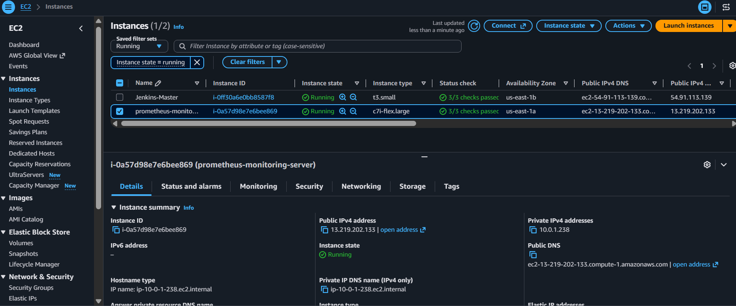
Step 4 — Connect using Git Bash on Windows
Open Git Bash in the folder containing jenkins.pem. For example, if it is in Downloads: cd ~/Downloads
chmod 400 jenkins.pem
ssh -i jenkins.pem ec2-user@YOUR_PUBLIC_IP
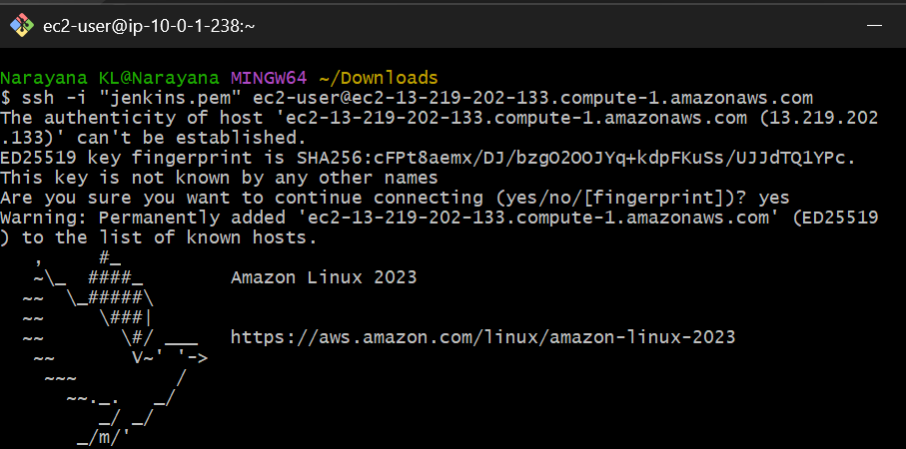
Replace YOUR_PUBLIC_IP with the actual IPv4 address from EC2.
At the first connection prompt, type yes if the displayed host fingerprint is expected. After connecting, verify the OS: cat /etc/os-release
whoami
uname -m
Expected results include Amazon Linux 2023, ec2-user, and x86_64 for an x86 instance.
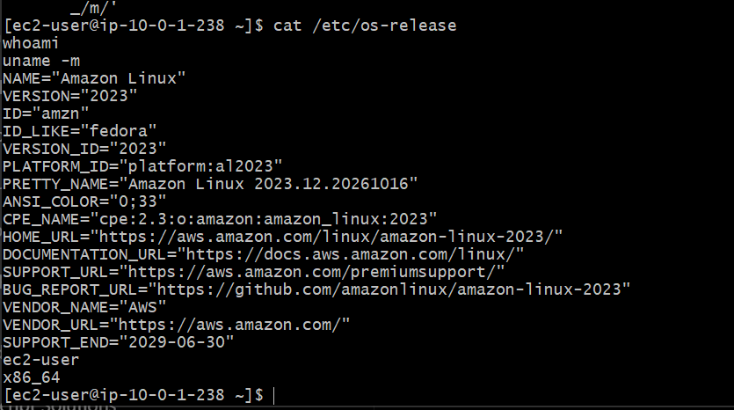
Task 1 — Install Prometheus
Prometheus will collect its own metrics first. In Task 2, we'll add Node Exporter for CPU, memory, disk, and filesystem metrics. This follows the official Prometheus installation approach using precompiled binaries.
 Prometheus +1
Step 5 — Update the server and install prerequisites
Run these commands in your SSH session:
sudo dnf update -y
sudo dnf install -y wget tar gzip curl
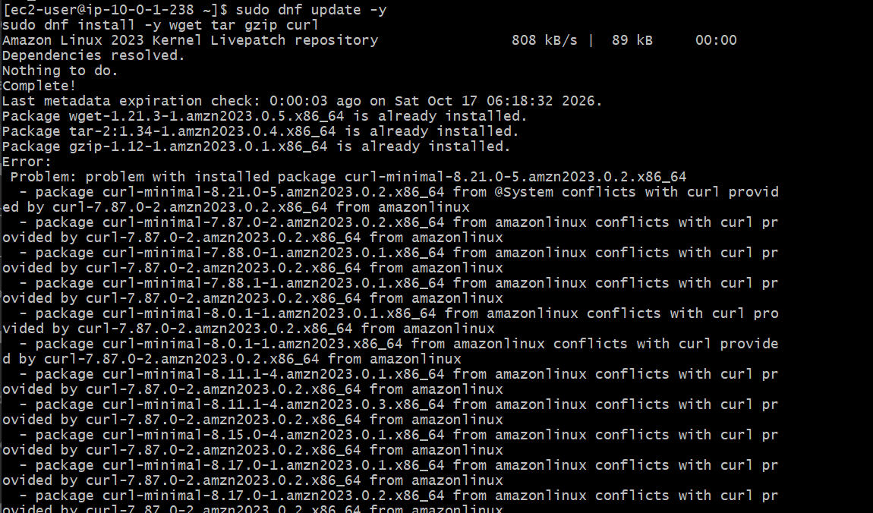
Create a dedicated service account and the required directories:
sudo useradd --no-create-home --shell /sbin/nologin prometheus
sudo mkdir -p /etc/prometheus
sudo mkdir -p /var/lib/Prometheus
Step 6 — Download and install Prometheus
The following commands retrieve the latest published release tag and download the matching Linux x86-64 archive.
cd /tmp
VERSION=$(curl -fsSL \
https://api.github.com/repos/prometheus/prometheus/releases/latest \
| grep '"tag_name":' \
| head -1 \
| cut -d '"' -f 4)
VERSION=${VERSION#v}
echo "Installing Prometheus version: $VERSION"
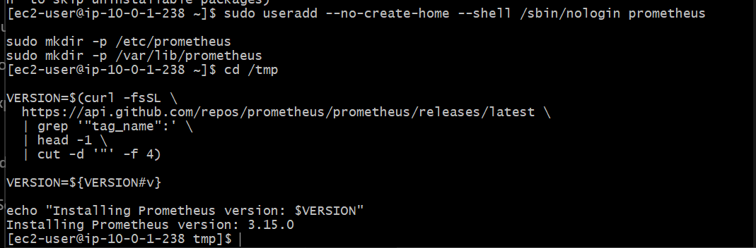

Download and extract it:
wget "https://github.com/prometheus/prometheus/releases/download/v${VERSION}/prometheus-${VERSION}.linux-amd64.tar.gz"
tar -xzf "prometheus-${VERSION}.linux-amd64.tar.gz"
cd "prometheus-${VERSION}.linux-amd64"
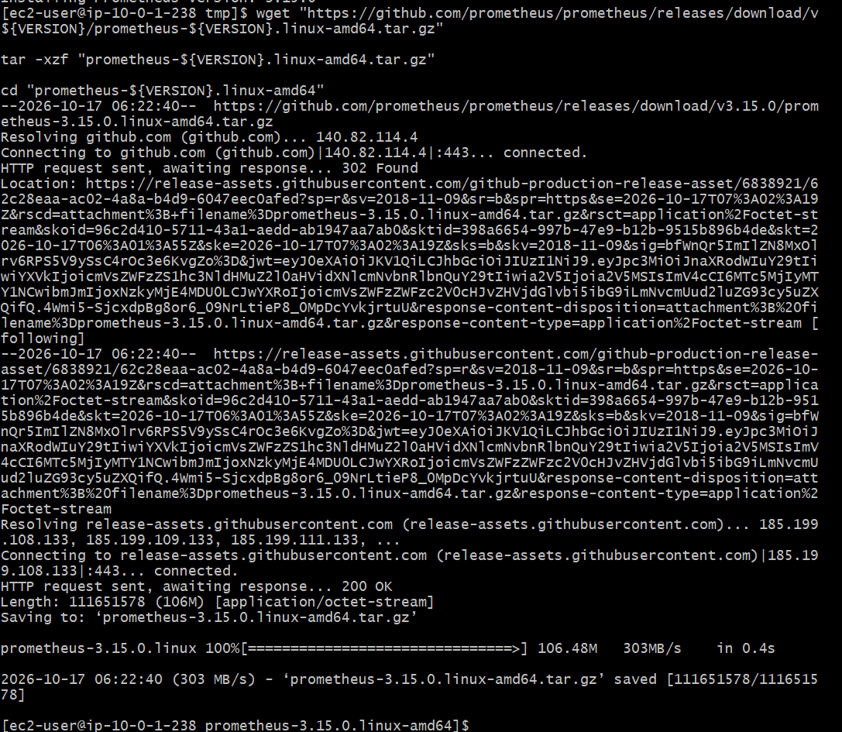
Install the binaries: sudo install -m 0755 prometheus /usr/local/bin/prometheus
sudo install -m 0755 promtool /usr/local/bin/promtool
Install the console assets: sudo cp -r consoles /etc/prometheus/
sudo cp -r console_libraries /etc/prometheus/
Set ownership:
sudo chown -R prometheus:prometheus /etc/prometheus
sudo chown -R prometheus:prometheus /var/lib/prometheus
prometheus --version
You should see the installed Prometheus version.
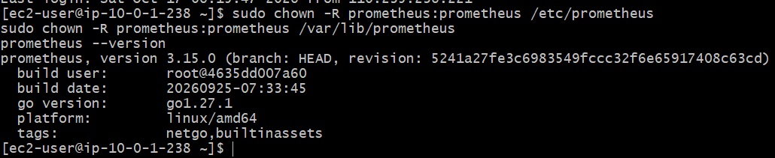
Step 7 — Configure prometheus.yml
Create the configuration file: sudo tee /etc/prometheus/prometheus.yml > /dev/null <<'EOF'
global:
scrape_interval: 15s
evaluation_interval: 15s
scrape_configs:
- job_name: prometheus
static_configs:
- targets: ["localhost:9090"]
EOF
Set ownership and validate the YAML configuration: sudo chown prometheus:prometheus /etc/prometheus/prometheus.yml
sudo promtool check config /etc/prometheus/prometheus.yml
Expected output: SUCCESS: /etc/prometheus/prometheus.yml is valid prometheus config file syntax
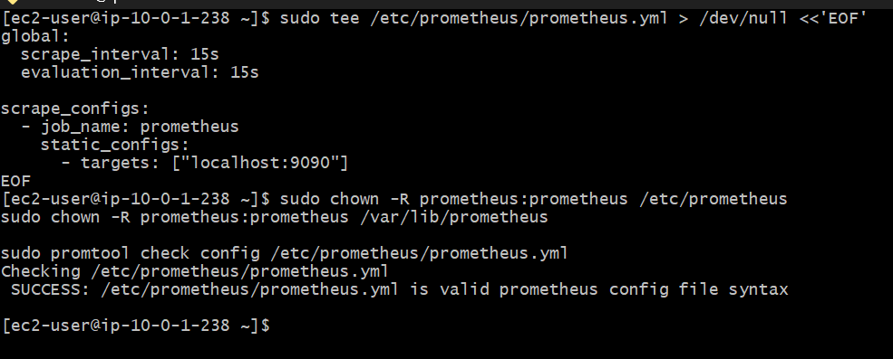
Step 8 — Start Prometheus temporarily
We'll configure Prometheus to start automatically with systemd in Task 4. For now, start it manually to verify the installation.
sudo -u prometheus nohup /usr/local/bin/prometheus \
--config.file=/etc/prometheus/prometheus.yml \
--storage.tsdb.path=/var/lib/prometheus \
--web.listen-address=127.0.0.1:9090 \
> /tmp/prometheus.log 2>&1 < /dev/null &
Notice that it listens on 127.0.0.1, so the web interface is not exposed directly to the internet.
Check readiness:
sleep 3
curl -s http://127.0.0.1:9090/-/ready
Expected response:
Prometheus Server is Ready.
If readiness fails, check the log:
sudo tail -50 /tmp/prometheus.log
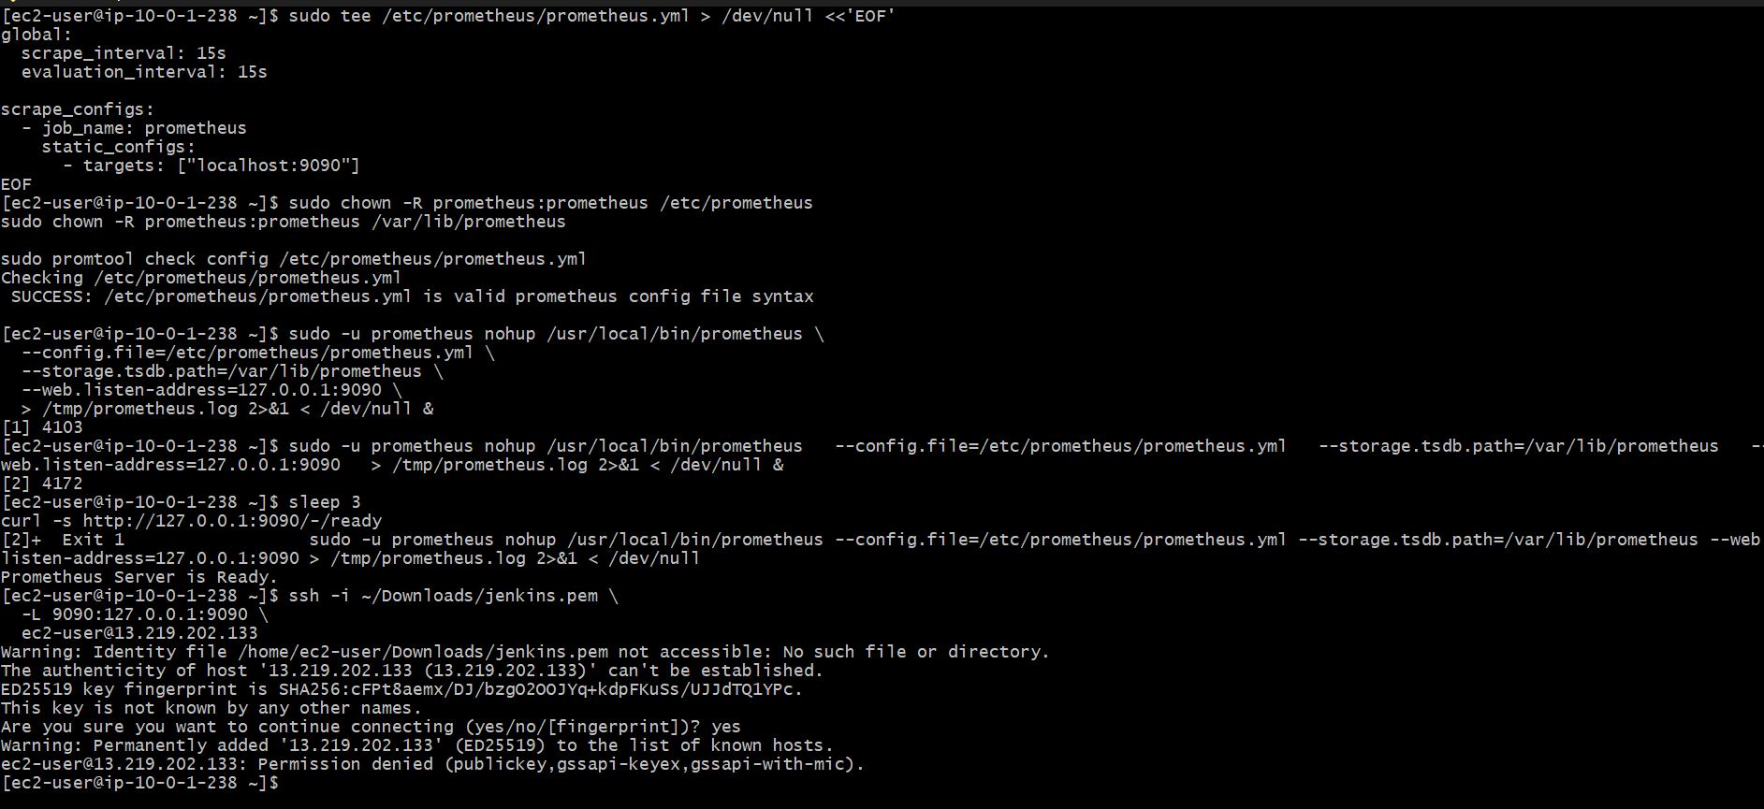
Step 9 — Open the Prometheus web interface
On your Windows computer, open a second Git Bash window and run:
ssh -i ~/Downloads/jenkins.pem \
-L 9090:127.0.0.1:9090 \
ec2-user@YOUR_PUBLIC_IP
Replace YOUR_PUBLIC_IP with the instance's public IPv4 address. Keep this SSH session open.
Now visit: http://localhost:9090 — Prometheus Web UI
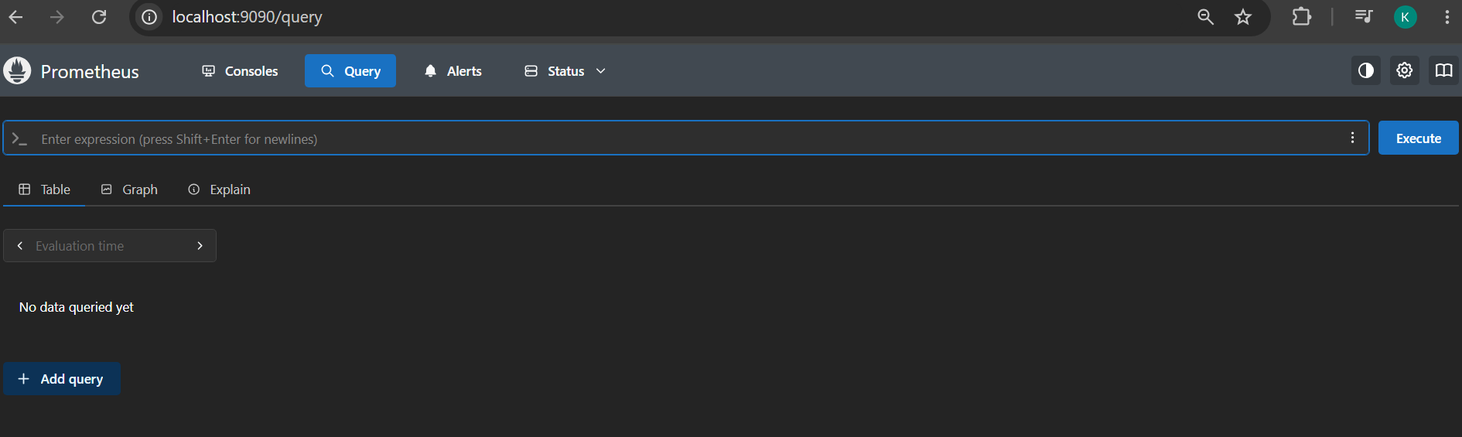
Open Status → Targets. You should see the prometheus job with its endpoint at localhost:9090 and state UP.
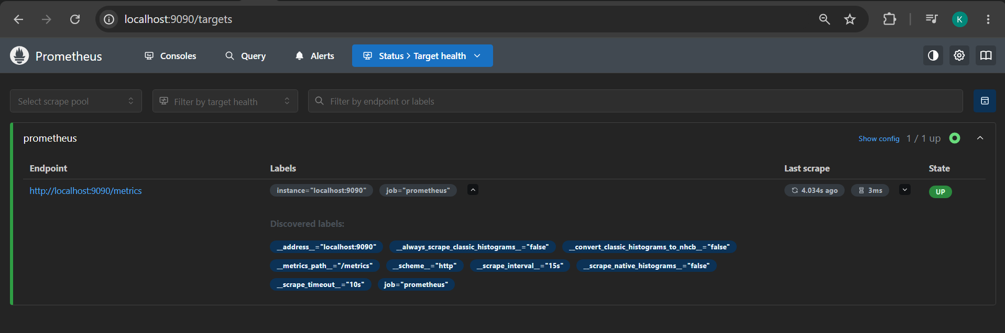
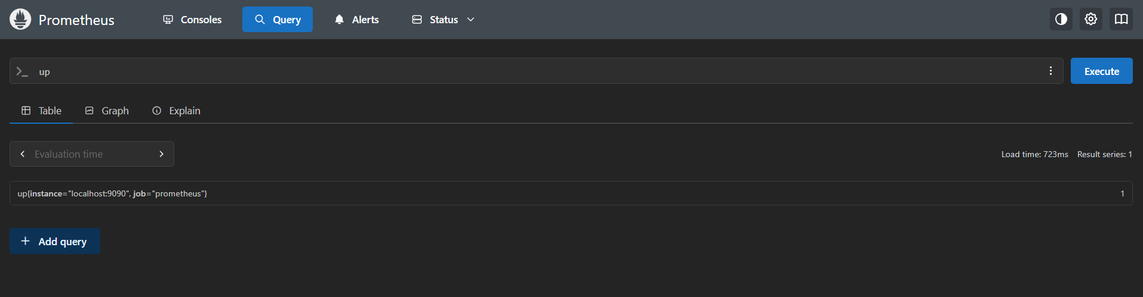
Your checkpoint
Complete the steps above, then send me the output of these three commands from the EC2 server:
prometheus --version
sudo promtool check config /etc/prometheus/prometheus.yml
curl -s http://127.0.0.1:9090/-/ready
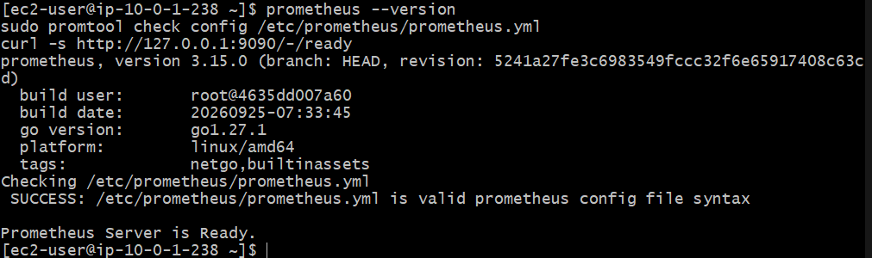
Task 2 — Install and Configure Node Exporter
Node Exporter collects server metrics such as CPU, RAM, disk space, filesystem usage, and network traffic.
Step 1 — Download Node Exporter
Run these commands in your existing EC2 SSH session:
cd /tmp
VERSION=$(curl -fsSL \
https://api.github.com/repos/prometheus/node_exporter/releases/latest \
| grep '"tag_name":' \
| head -1 \
| cut -d '"' -f 4)
VERSION=${VERSION#v}
echo "Node Exporter version: $VERSION"
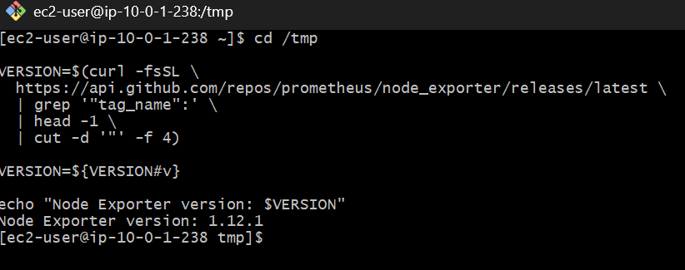
Download and extract:
wget "https://github.com/prometheus/node_exporter/releases/download/v${VERSION}/node_exporter-${VERSION}.linux-amd64.tar.gz"
tar -xzf "node_exporter-${VERSION}.linux-amd64.tar.gz"
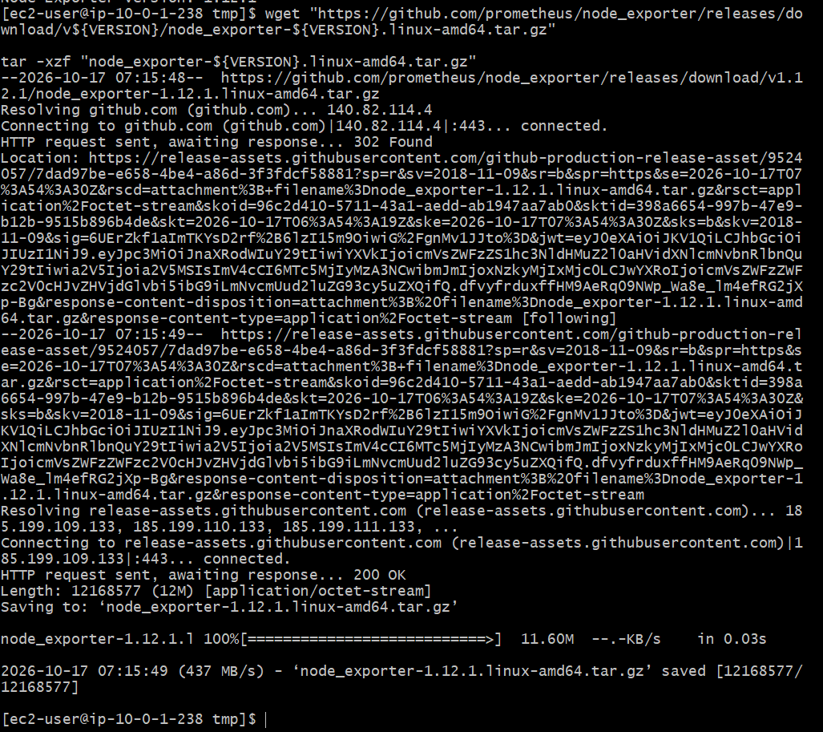
Step 2 — Install the binary
sudo install -m 0755 \
"/tmp/node_exporter-${VERSION}.linux-amd64/node_exporter" \
/usr/local/bin/node_exporter
Verify: /usr/local/bin/node_exporter –version
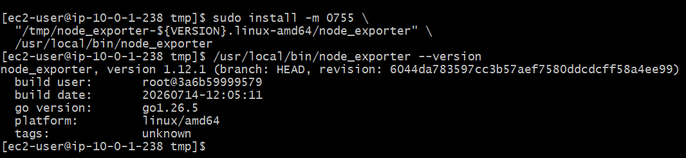
Step 3 — Create a dedicated user
sudo useradd --no-create-home --shell /sbin/nologin node_exporter
If the user already exists, the command may report that; that's fine.
Step 4 — Run Node Exporter temporarily
sudo -u node_exporter nohup /usr/local/bin/node_exporter \
--web.listen-address=127.0.0.1:9100 \
> /tmp/node_exporter.log 2>&1 < /dev/null &
Verify that metrics are available:
curl -s http://127.0.0.1:9100/metrics | head
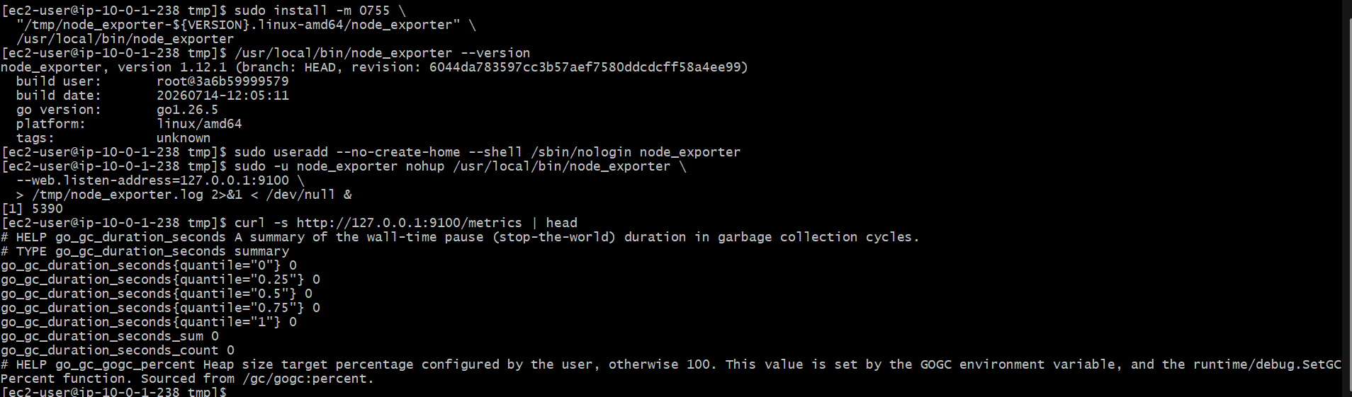
Connect Node Exporter to Prometheus
Step 1 — Update prometheus.yml
Run this on your EC2 monitoring server:
sudo tee /etc/prometheus/prometheus.yml > /dev/null <<'EOF'
global: scrape_interval: 15s
evaluation_interval: 15s

scrape_configs:
- job_name: prometheus
static_configs:
- targets: ["localhost:9090"]
- job_name: node_exporter
static_configs:
- targets: ["localhost:9100"]
EOF
Because both processes are currently running on the same server and bound to localhost, these targets are correct.
Step 2 — Validate the configuration
sudo promtool check config /etc/prometheus/prometheus.yml
Expected:
SUCCESS: /etc/prometheus/prometheus.yml is valid prometheus config file syntax
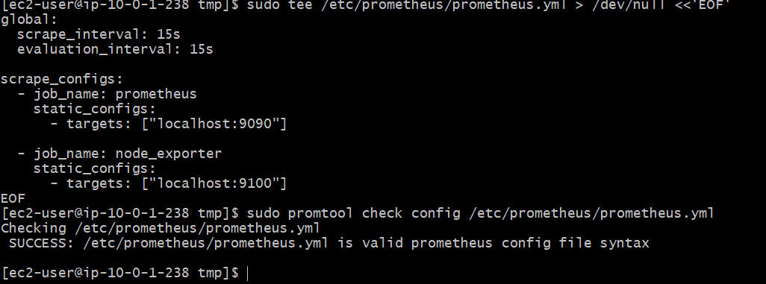
Step 3 — Reload Prometheus
Prometheus supports configuration reload when enabled with --web.enable-lifecycle. We did not enable that option at startup, so restart the temporary process for now:
sudo pkill -x prometheus
Start it again:
sudo -u prometheus nohup /usr/local/bin/prometheus \
--config.file=/etc/prometheus/prometheus.yml \
--storage.tsdb.path=/var/lib/prometheus \
--web.listen-address=127.0.0.1:9090 \
> /tmp/prometheus.log 2>&1 < /dev/null &
Verify readiness:
sleep 3
curl -s http://127.0.0.1:9090/-/ready
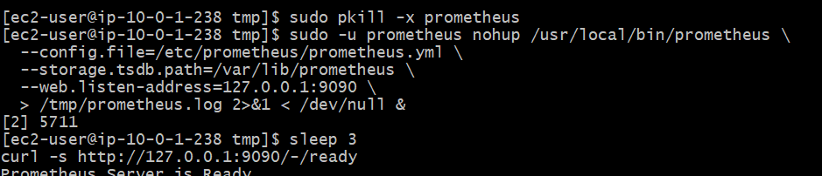
Step 4 — Verify both targets
Run:
curl -s http://127.0.0.1:9090/api/v1/targets \
| grep -E '"job"|"health"|"scrapeUrl"'
Look for both jobs:
- prometheus — up
- node_exporter — up
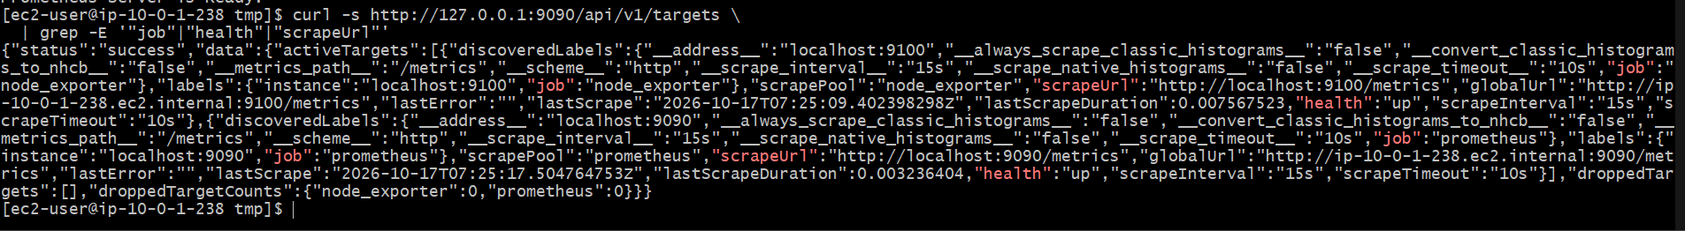

You can also verify the actual server metrics:
curl -s 'http://127.0.0.1:9090/api/v1/query?query=node_memory_MemAvailable_bytes'
The response should contain a numeric value for available memory.
Open the Prometheus UI
Since Prometheus is listening on 127.0.0.1:9090, open Windows Git Bash on your computer (not the EC2 terminal) and run:
ssh -i ~/Downloads/jenkins.pem \
-N -L 9090:127.0.0.1:9090 \
ec2-user@13.219.202.133
Keep this terminal open. Then open: Prometheus Web UI
Open in your Windows browser
Open Prometheus
Verify both targets are UP
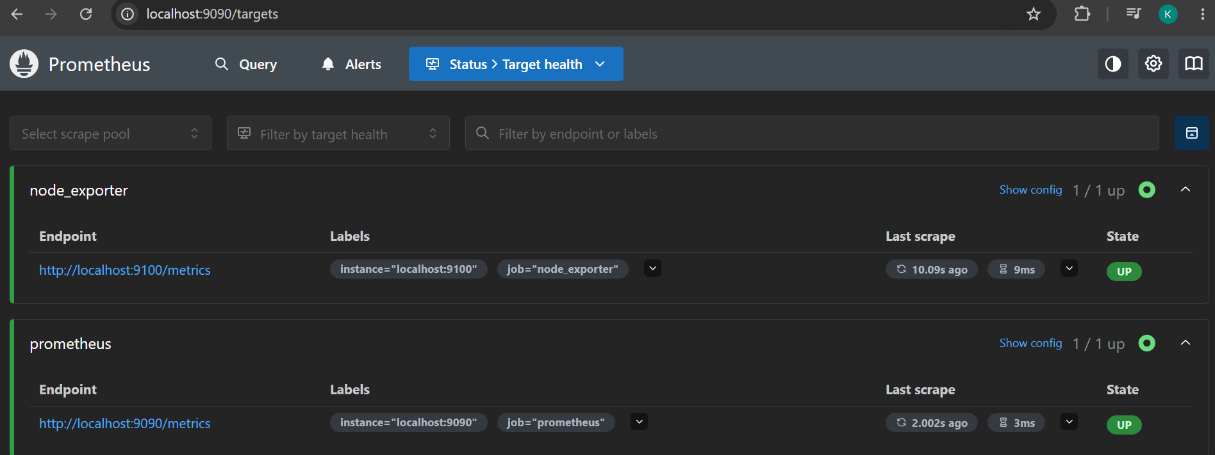
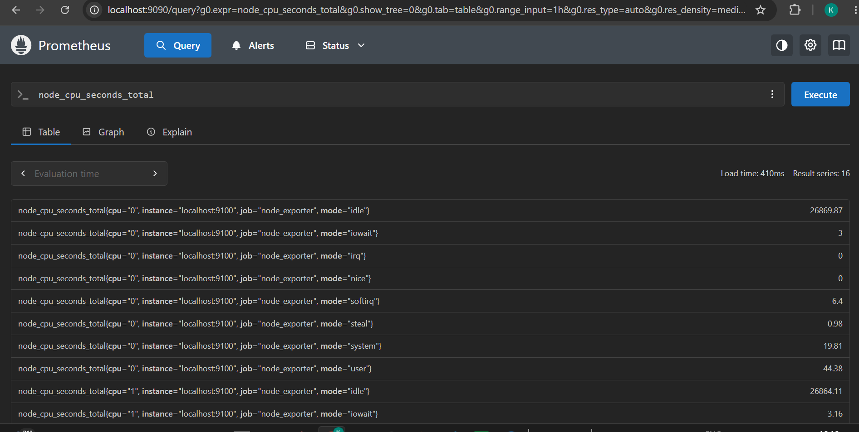
Task 3 — Install and Configure SNMP Exporter
We'll install SNMP Exporter on your existing Amazon Linux 2023 monitoring server (ip-10-0-1-238).
Since you don't have a physical or virtual SNMP device yet, we'll validate that the exporter starts, serves its metrics endpoint, and can be scraped by Prometheus. Actual router and switch metrics will require an SNMP-enabled device later.
Monitoring stack so far
Prometheus — port 9090
Working
Node Exporter — port 9100
Working
SNMP Exporter — port 9116
To install
Step 1 — Download SNMP Exporter
The official release page currently lists SNMP Exporter 0.30.1. We'll use that release for this lab.

GitHub +1
Run these commands on your EC2 server:
cd /tmp
VERSION=0.30.1
wget "https://github.com/prometheus/snmp_exporter/releases/download/v${VERSION}/snmp_exporter-${VERSION}.linux-amd64.tar.gz"
tar -xzf "snmp_exporter-${VERSION}.linux-amd64.tar.gz"
ls -la "/tmp/snmp_exporter-${VERSION}.linux-amd64"
You should see the snmp_exporter binary and snmp.yml configuration file.
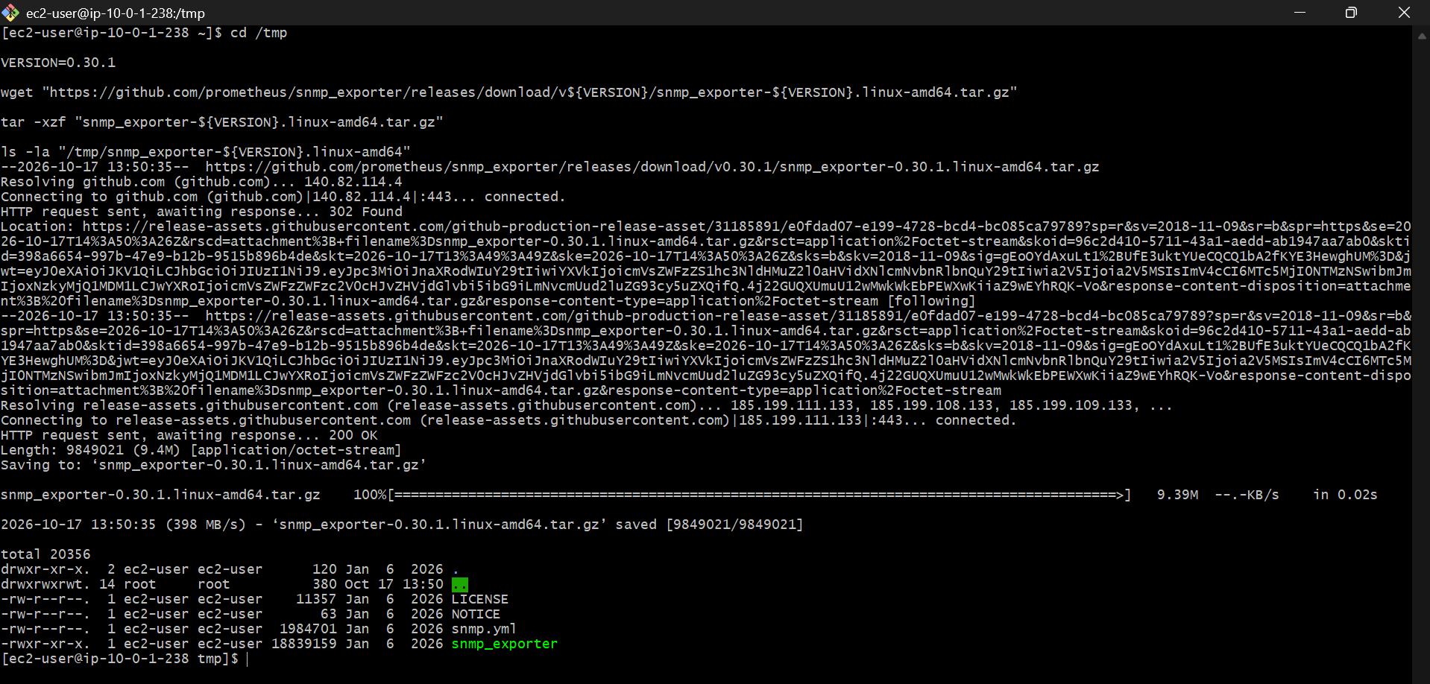
Step 2 — Install the binary and configuration
sudo install -m 0755 \
/tmp/snmp_exporter-0.30.1.linux-amd64/snmp_exporter \
/usr/local/bin/snmp_exporter
sudo mkdir -p /etc/snmp_exporter
sudo install -m 0644 \
/tmp/snmp_exporter-0.30.1.linux-amd64/snmp.yml \
/etc/snmp_exporter/snmp.yml
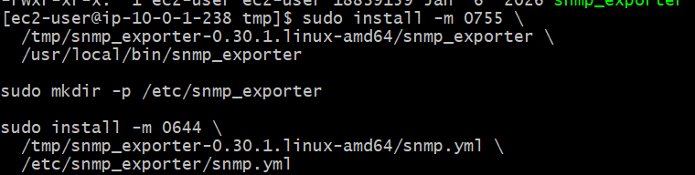
Verify the installation:
/usr/local/bin/snmp_exporter --version
Check that the configuration file exists:
sudo ls -lh /etc/snmp_exporter/snmp.yml
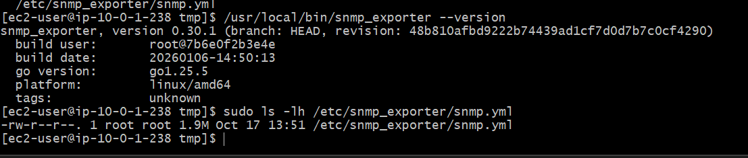
Step 3 — Create a dedicated service account
sudo useradd --no-create-home --shell /sbin/nologin snmp_exporter
sudo chown -R root:root /etc/snmp_exporter
sudo chmod 755 /etc/snmp_exporter
sudo chmod 644 /etc/snmp_exporter/snmp.yml
If the account already exists, you can continue without recreating it.
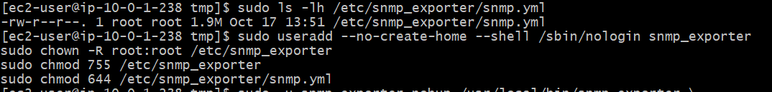
Step 4 — Start SNMP Exporter
We'll bind it to localhost on port 9116. No security-group changes are required.
sudo -u snmp_exporter nohup /usr/local/bin/snmp_exporter \
--config.file=/etc/snmp_exporter/snmp.yml \
--web.listen-address=127.0.0.1:9116 \
> /tmp/snmp_exporter.log 2>&1 < /dev/null &
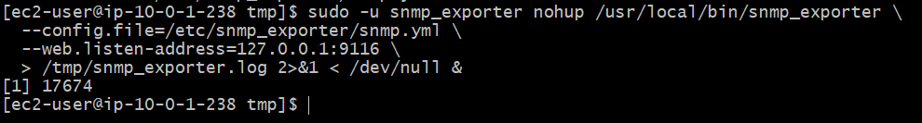
Wait a few seconds, then check the endpoint:
sleep 3
curl -s http://127.0.0.1:9116/metrics | head
You should see exporter metrics beginning with # HELP and # TYPE.
If the endpoint does not respond, inspect the log:
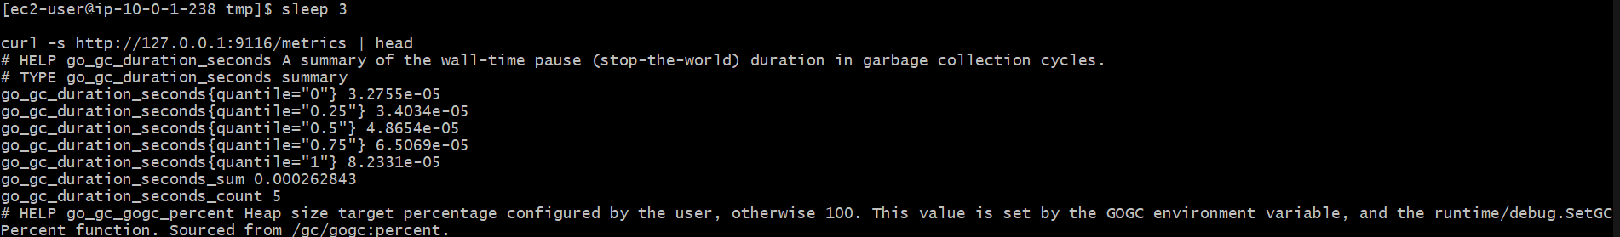
sudo tail -50 /tmp/snmp_exporter.log
Step 5 — Verify the exporter configuration
Check whether the configuration includes the default if_mib module and public_v2 authentication:
grep -nE '^modules:|^ if_mib:|^auths:|^ public_v2:' \
/etc/snmp_exporter/snmp.yml
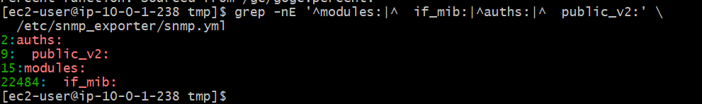
The default configuration supports SNMP collection from compatible devices. The exporter itself can run without a network device, but we cannot validate actual interface or router metrics until a reachable SNMP agent is available.
Step 6: Add SNMP Exporter to Prometheus
First, back up the current configuration:
sudo cp /etc/prometheus/prometheus.yml \
/etc/prometheus/prometheus.yml.bak
View the current file to make sure the Prometheus and Node Exporter jobs are still present:
sudo cat /etc/prometheus/prometheus.yml
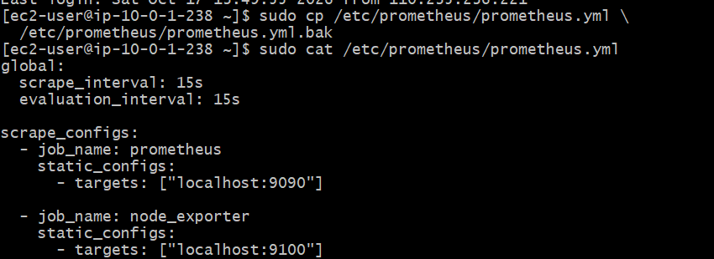
Now append the SNMP Exporter scrape job:
sudo tee -a /etc/prometheus/prometheus.yml > /dev/null <<'EOF'
- job_name: snmp_exporter
static_configs:
- targets: ["localhost:9116"]
EOF
Validate the configuration:
sudo promtool check config /etc/prometheus/prometheus.yml
Expected:
SUCCESS: /etc/prometheus/prometheus.yml is valid prometheus config file syntax
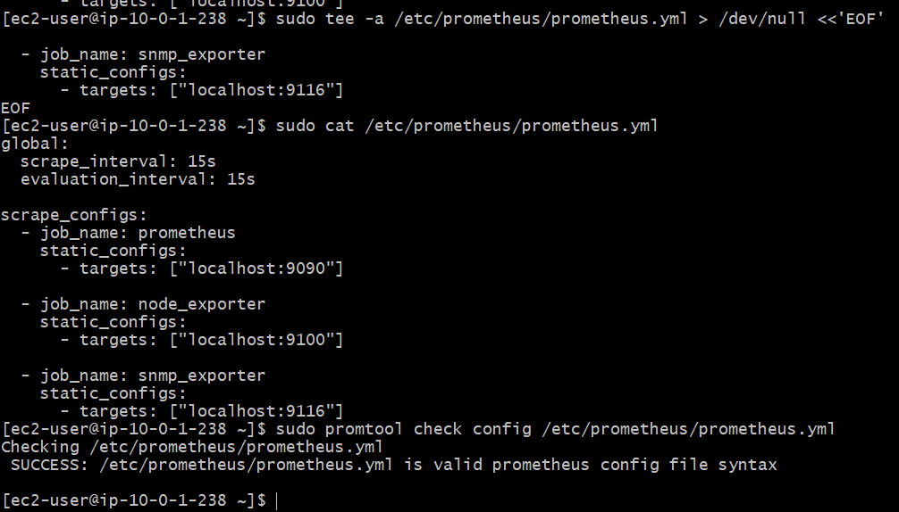
Step 7 — Restart Prometheus to load the configuration
Your existing UI tunnel can remain open. Run these commands in your EC2 SSH terminal:
sudo pkill -x prometheus
Start Prometheus again:
sudo -u prometheus nohup /usr/local/bin/prometheus \
--config.file=/etc/prometheus/prometheus.yml \
--storage.tsdb.path=/var/lib/prometheus \
--web.listen-address=127.0.0.1:9090 \
> /tmp/prometheus.log 2>&1 < /dev/null &
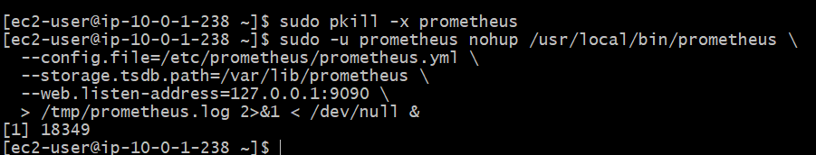
Check readiness:
sleep 3
curl -s http://127.0.0.1:9090/-/ready
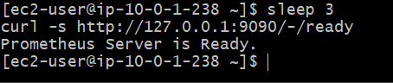
Step 8 — Verify in your existing Prometheus UI
Open your existing browser tab at http://localhost:9090.
1. Open Status → Targets
Confirm these three jobs are UP:
- prometheus — localhost:9090
- node_exporter — localhost:9100
- snmp_exporter — localhost:9116
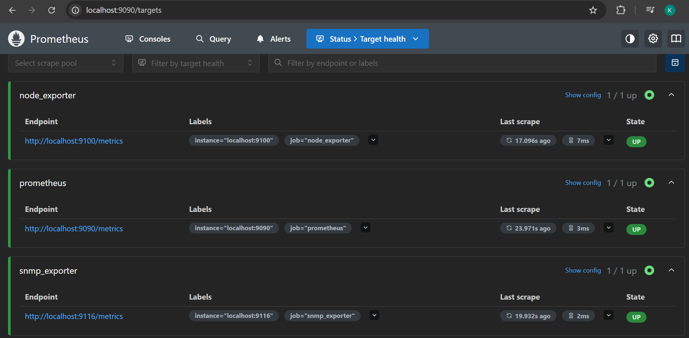
2. Test a query
Open the query page and execute:
up{job="snmp_exporter"}
Expected result: 1.
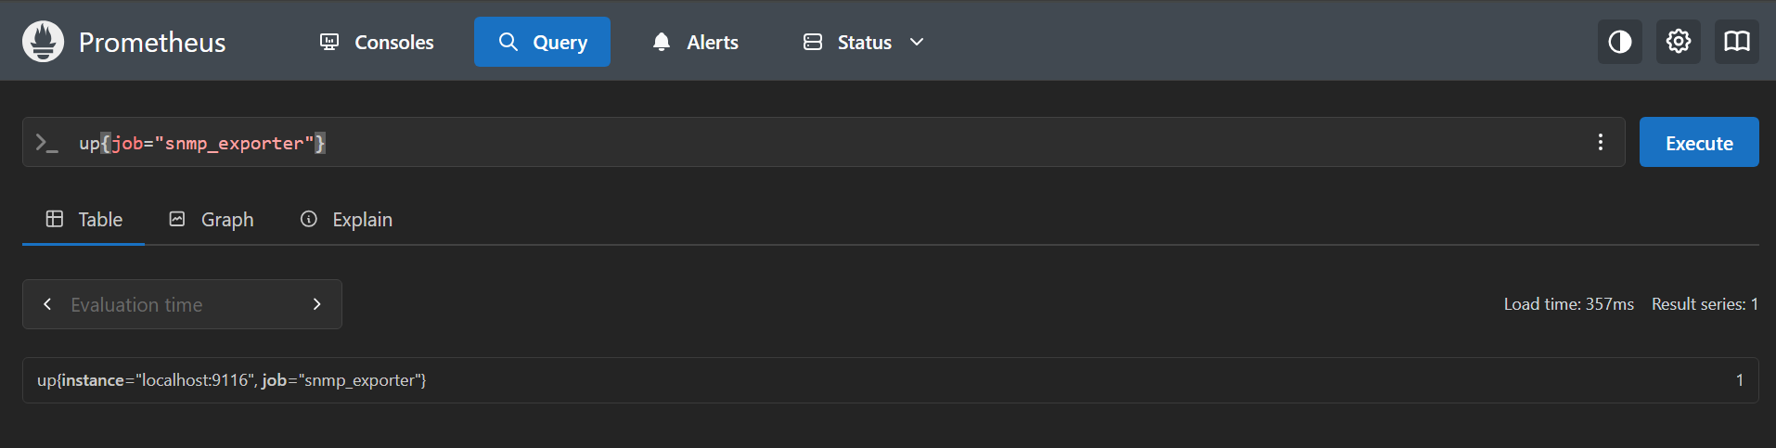
Task 4 — Configure Prometheus as a systemd Service
Step 1: Create the service file
Run this on your EC2 terminal:
sudo tee /etc/systemd/system/prometheus.service > /dev/null <<'EOF'
[Unit]
Description=Prometheus Monitoring
Wants=network-online.target
After=network-online.target
[Service]
User=prometheus
Group=prometheus
Type=simple
ExecStart=/usr/local/bin/prometheus \
--config.file=/etc/prometheus/prometheus.yml \
--storage.tsdb.path=/var/lib/prometheus \
--web.listen-address=127.0.0.1:9090
Restart=on-failure
RestartSec=5s
[Install]
WantedBy=multi-user.target
EOF
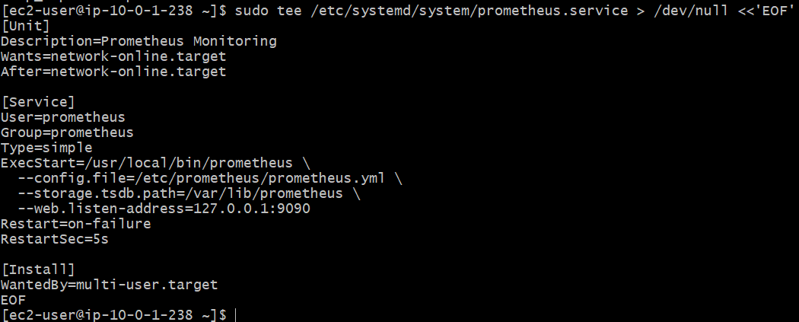
Step 2: Verify and enable the service
First, verify that the file exists:
sudo cat /etc/systemd/system/prometheus.service
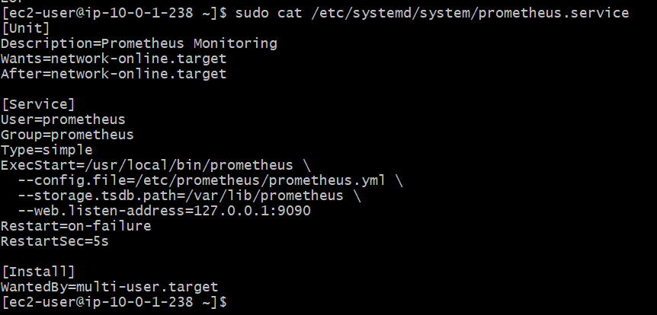
Then reload systemd and enable Prometheus:
sudo systemctl daemon-reload
sudo systemctl enable Prometheus
Step 3: Replace the temporary Prometheus process
Your existing Prometheus process is running outside systemd, so stop it before starting the service:
sudo pkill -x prometheus
sudo systemctl start prometheus
Check the service:
sudo systemctl status prometheus --no-pager
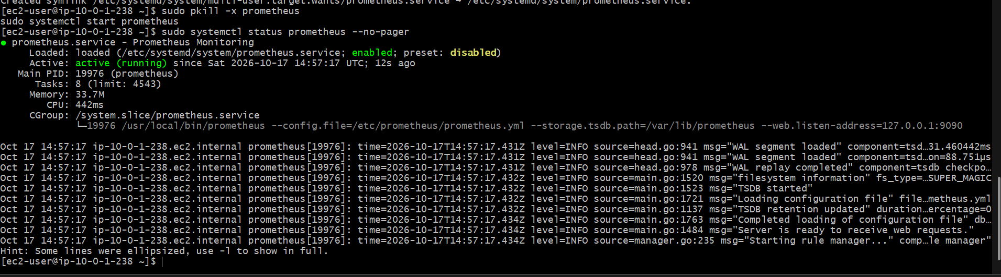
Step 4: Verify monitoring
curl -s http://127.0.0.1:9090/-/ready
Then check all targets again:
curl -s http://127.0.0.1:9090/api/v1/targets \
| python3 -c 'import sys,json; d=json.load(sys.stdin); [print(t["labels"].get("job"), t["health"]) for t in d["data"]["activeTargets"]]'
Expected results:
- prometheus.service — active (running)
- Prometheus readiness — Prometheus Server is Ready.
- prometheus — up
- node_exporter — up
- snmp_exporter — up
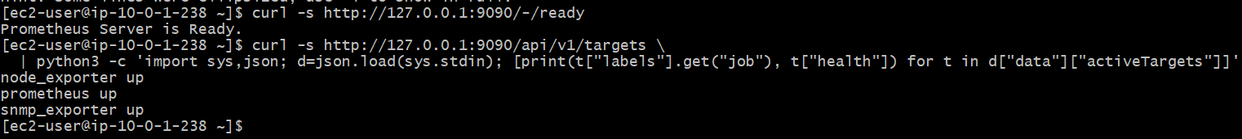
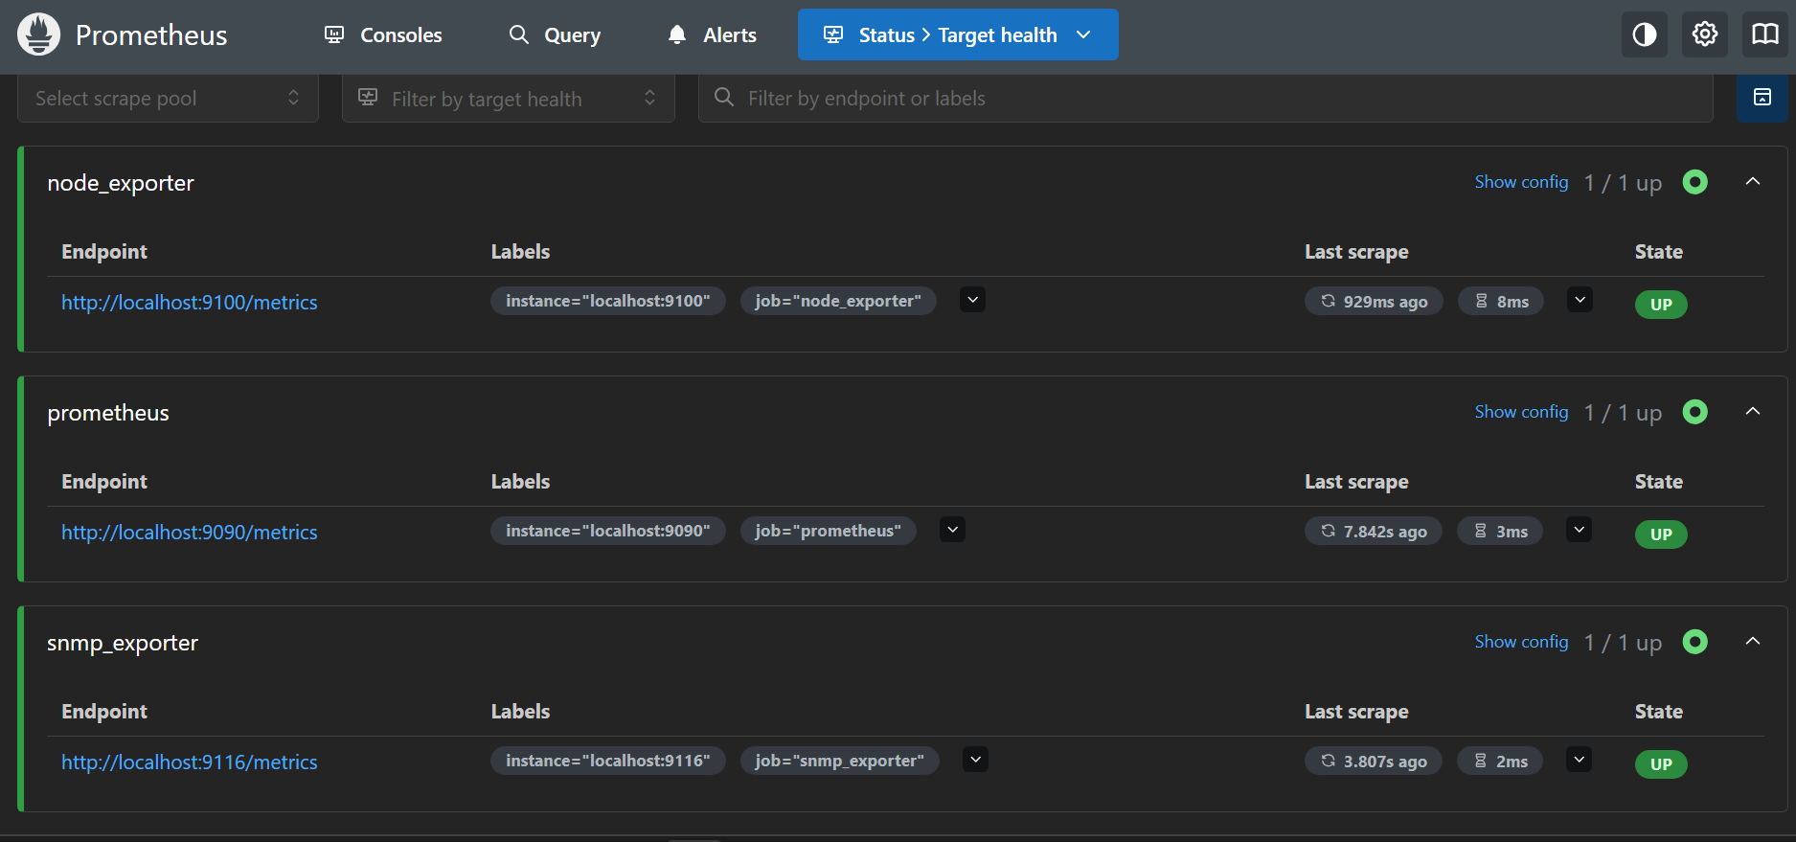
Task 5 — Install and Configure Alertmanager with Email Alerts
Step 1: Install Alertmanager
We'll use Alertmanager 0.34.1, the latest release listed on its official GitHub releases page at the time of this setup.
GitHub
Run these commands on your EC2 instance: cd /tmp
wget https://github.com/prometheus/alertmanager/releases/download/v0.34.1/alertmanager-0.34.1.linux-amd64.tar.gz
tar -xzf alertmanager-0.34.1.linux-amd64.tar.gz
sudo install -m 0755 alertmanager-0.34.1.linux-amd64/alertmanager /usr/local/bin/alertmanager
sudo install -m 0755 alertmanager-0.34.1.linux-amd64/amtool /usr/local/bin/amtool
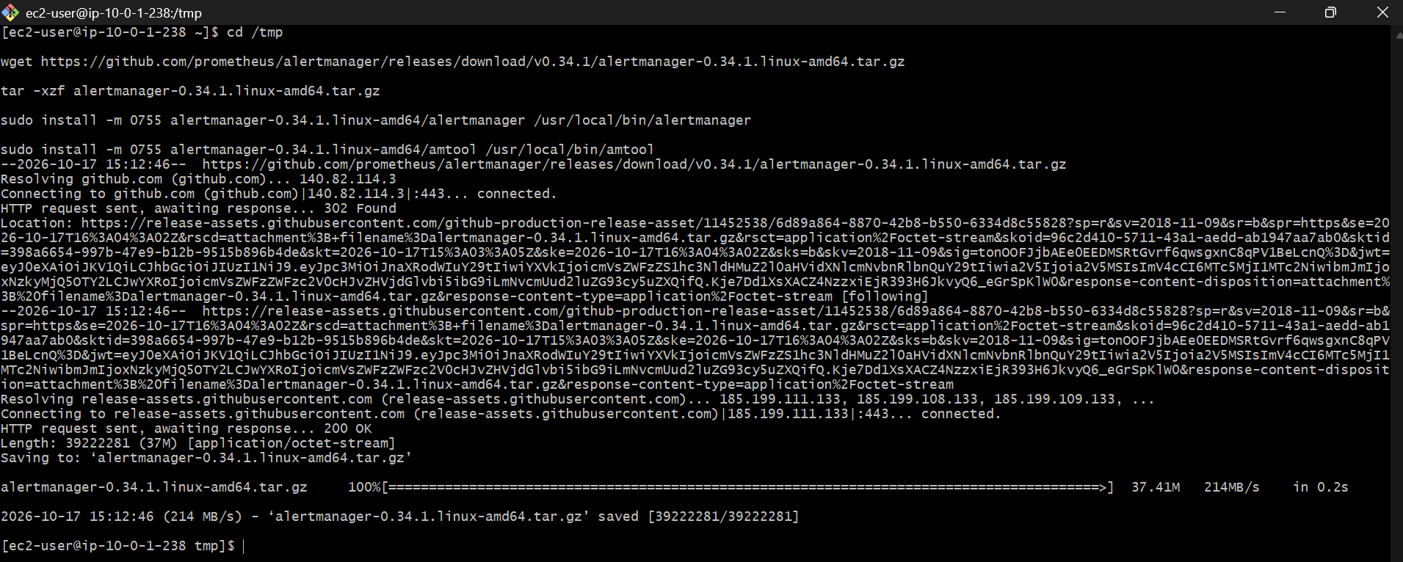
Verify the installation:
/usr/local/bin/alertmanager --version
/usr/local/bin/amtool –version
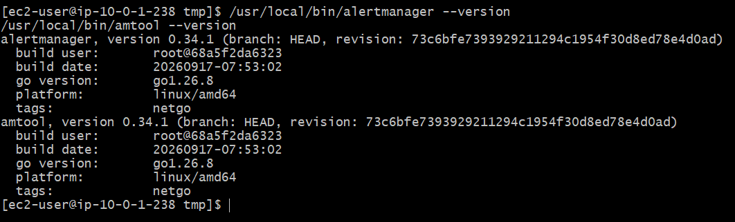
Step 2: Create the Alertmanager service account and directories
sudo useradd --system --no-create-home --shell /sbin/nologin alertmanager
If the user already exists, that command may report that it exists; you can continue.
sudo mkdir -p /etc/alertmanager /var/lib/alertmanager
sudo chown -R alertmanager:alertmanager /etc/alertmanager /var/lib/alertmanager
Verify 2-Step Verification
On your computer, open:
Google Account — 2-Step Verification
Confirm that the status shows On.
Generate the Alertmanager App Password
If it is On, open:
Google App Passwords
- Enter Alertmanager as the app name if prompted.
- Click Create.
- Copy the 16-character password Google generates.
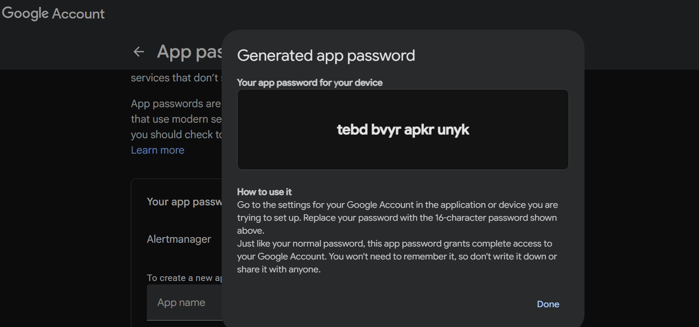
tebd bvyr apkr unyk
Step 3: Prepare the Gmail credentials
On EC2, create a private file for your Gmail app password:
sudo install -o root -g alertmanager -m 0640 /dev/null /etc/alertmanager/gmail_app_password
sudo nano /etc/alertmanager/gmail_app_password
In the editor, paste only the Google app password, without spaces or quotation marks, then save and exit:
- Save: Ctrl+O, then Enter
- Exit: Ctrl+X
The password is stored locally and is not displayed in your terminal commands. If needed, adjust its ownership and permissions:
sudo chown root:alertmanager /etc/alertmanager/gmail_app_password
sudo chmod 640 /etc/alertmanager/gmail_app_password
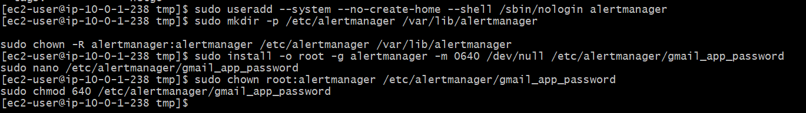
Step 4: Configure Alertmanager
First, we need your actual sender and recipient addresses. The recipient wasn't provided, so don't start the service with placeholder addresses.
Run: sudo nano /etc/alertmanager/alertmanager.yml
Use this configuration, replacing the two email placeholders with real addresses:
global:
smtp_smarthost: 'smtp.gmail.com:587'
smtp_from: 'SENDER@gmail.com'
smtp_auth_username: 'SENDER@gmail.com'
smtp_auth_password_file: '/etc/alertmanager/gmail_app_password'
smtp_require_tls: true
route:
receiver: 'gmail-notifications'
group_by: ['alertname']
group_wait: 30s
group_interval: 5m
repeat_interval: 4h
receivers:
- name: 'gmail-notifications'
email_configs:
- to: 'RECIPIENT@example.com'
send_resolved: true
Save with Ctrl+O, Enter, then Ctrl+X.
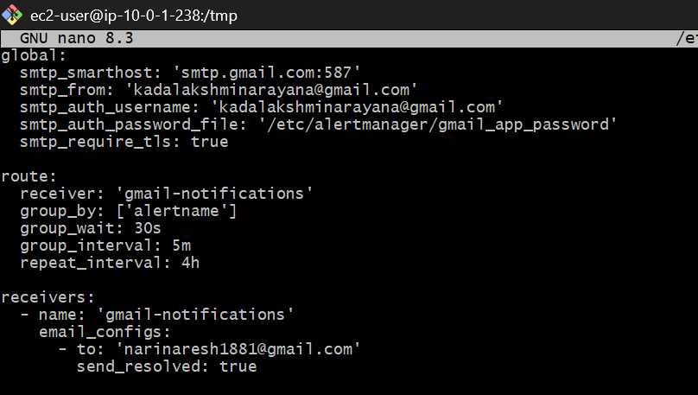
Restrict the configuration file:
sudo chown root:alertmanager /etc/alertmanager/alertmanager.yml
sudo chmod 640 /etc/alertmanager/alertmanager.yml
Validate the configuration:
sudo -u alertmanager /usr/local/bin/amtool check-config /etc/alertmanager/alertmanager.yml
The validation should report that the configuration is valid. Alertmanager's SMTP settings and email receiver structure follow the official configuration documentation.
Prometheus
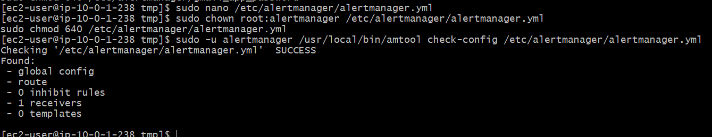
Step 5: Create the systemd service
sudo tee /etc/systemd/system/alertmanager.service > /dev/null <<'EOF'
[Unit]
Description=Prometheus Alertmanager
Wants=network-online.target
After=network-online.target
[Service]
User=alertmanager
Group=alertmanager
Type=simple
ExecStart=/usr/local/bin/alertmanager \
--config.file=/etc/alertmanager/alertmanager.yml \
--storage.path=/var/lib/alertmanager \
--web.listen-address=127.0.0.1:9093
Restart=on-failure
RestartSec=5s
[Install]
WantedBy=multi-user.target
EOF
Enable and start the service:
sudo systemctl daemon-reload
sudo systemctl enable --now alertmanager
sudo systemctl status alertmanager --no-pager
Verify readiness:
curl -s http://127.0.0.1:9093/-/ready
Expected:
Alertmanager is Ready.
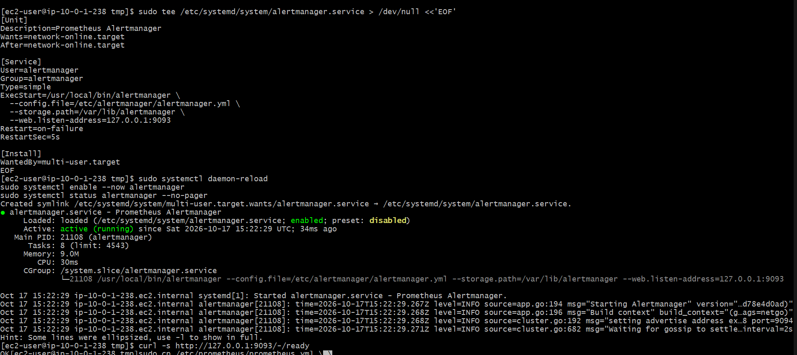
Step 6 — Create the missing test alert rule
Run these commands on your EC2 instance:
sudo mkdir -p /etc/prometheus/rules
sudo tee /etc/prometheus/rules/test-alert.yml > /dev/null <<'EOF'
groups:
- name: test-alerts
rules:
- alert: PrometheusAlertmanagerTest
expr: vector(1)
for: 30s
labels:
severity: warning
annotations:
summary: "Prometheus test alert"
description: "Testing Prometheus to Alertmanager email delivery."
EOF
Ensure Prometheus can read the rule:
sudo chown -R prometheus:prometheus /etc/prometheus/rules
sudo chmod 644 /etc/prometheus/rules/test-alert.yml
Validate the rule:
sudo promtool check rules /etc/prometheus/rules/test-alert.yml
Expected output should include:
SUCCESS: 1 rules found
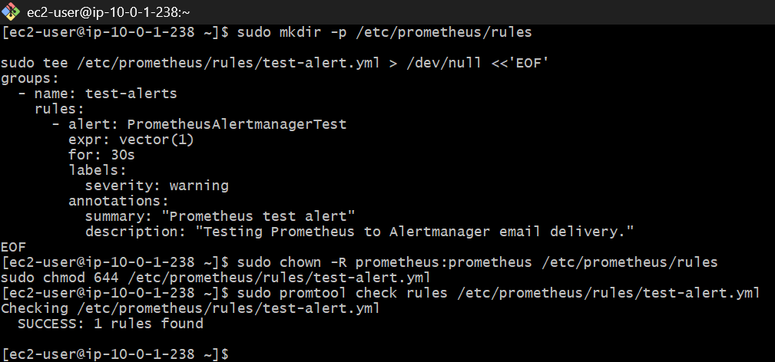
Step 7 — Verify Prometheus is configured to load the rule
Run:
sudo grep -A4 '^alerting:' /etc/prometheus/prometheus.yml
sudo grep -A2 '^rule_files:' /etc/prometheus/prometheus.yml
You should see Alertmanager at 127.0.0.1:9093 and the rule pattern /etc/prometheus/rules/*.yml.
If both are present, validate the main configuration again:
sudo promtool check config /etc/prometheus/prometheus.yml
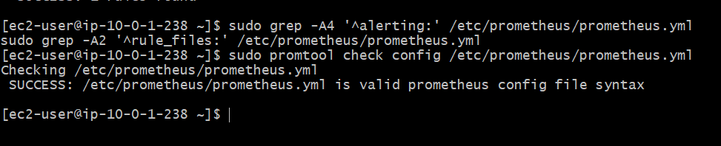
Step 8 — Restart Prometheus
sudo systemctl restart prometheus
sudo systemctl status prometheus --no-pager
Confirm readiness:
curl -s http://127.0.0.1:9090/-/ready
Expected:
Prometheus Server is Ready.
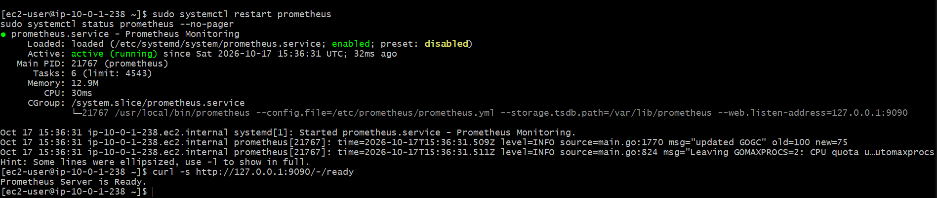
Step 4 — Check whether the test alert fires
Wait about 45–60 seconds, then run:
curl -s http://127.0.0.1:9090/api/v1/alerts \
| python3 -m json.tool
Look for PrometheusAlertmanagerTest with state firing.
Then check whether Alertmanager received the alert:
curl -s http://127.0.0.1:9093/api/v2/alerts \
| python3 -m json.tool
Step 5 — Verify Gmail delivery
Check the recipient inbox, including Spam, for the test alert email. If the alert appears in Alertmanager but no email arrives, run:
sudo journalctl -u alertmanager -n 80 --no-pager
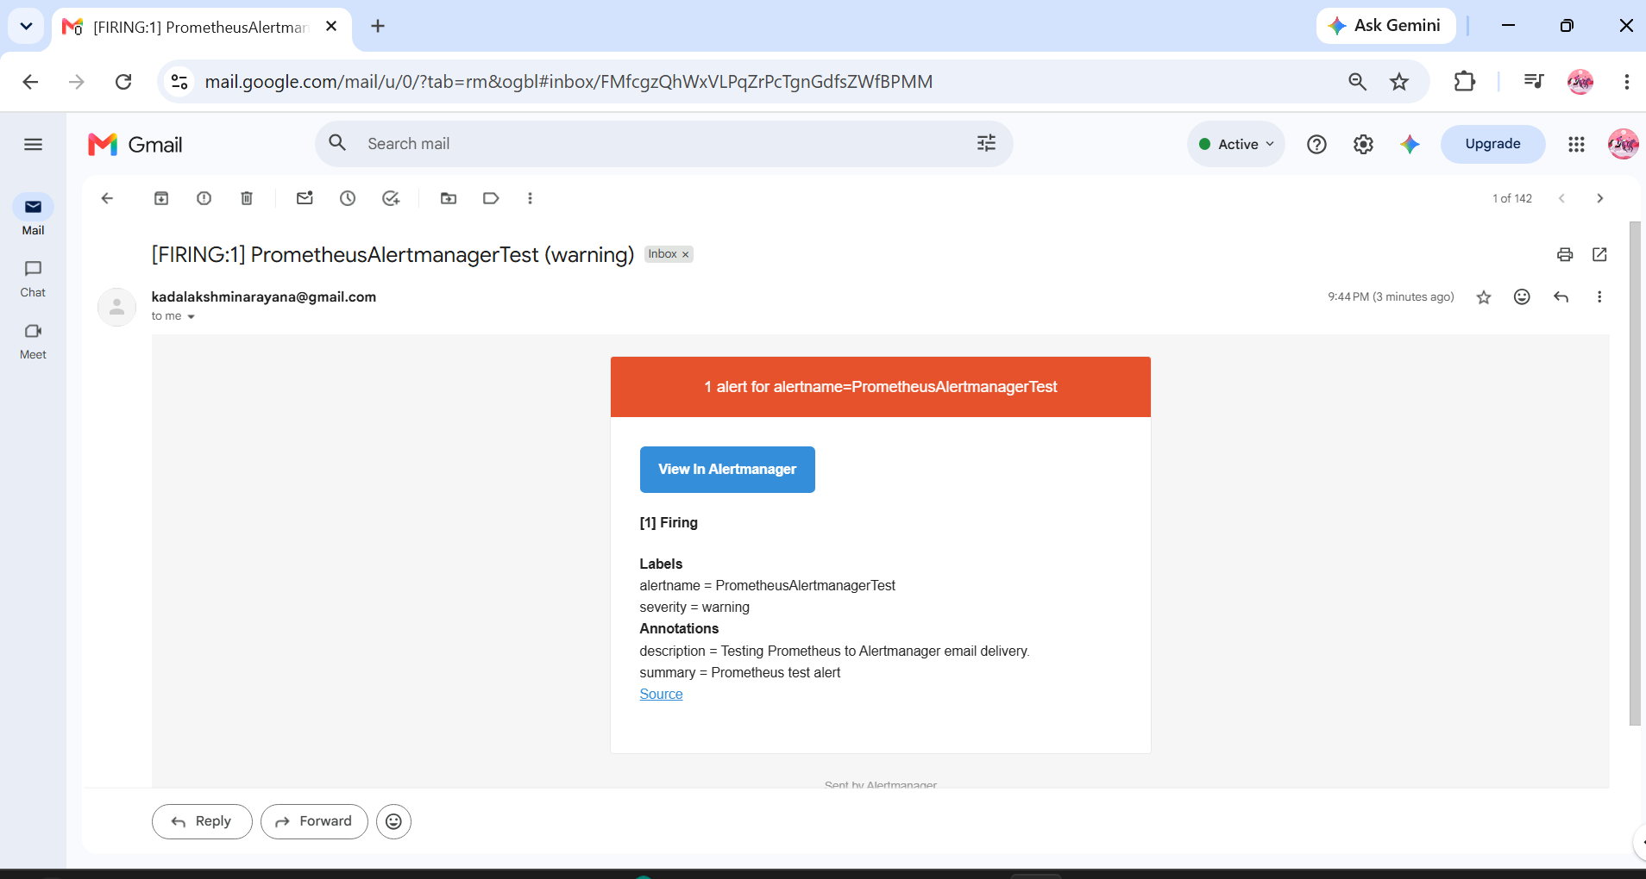
Task 6 — Install and Configure Grafana
Step 1: Add the official Grafana repository
We'll install Grafana using its official RPM repository on your Amazon Linux 2023 EC2 instance.
Run this command in your EC2 SSH terminal:
sudo tee /etc/yum.repos.d/grafana.repo > /dev/null <<'EOF'
[grafana]
name=Grafana OSS Repository
baseurl=https://rpm.grafana.com
repo_gpgcheck=1
enabled=1
gpgcheck=1
gpgkey=https://rpm.grafana.com/gpg.key
sslverify=1
sslcacert=/etc/pki/tls/certs/ca-bundle.crt
EOF
Verify Step 1
Run: cat /etc/yum.repos.d/grafana.repo
You should see the repository configuration, including baseurl=https://rpm.grafana.com and enabled=1.
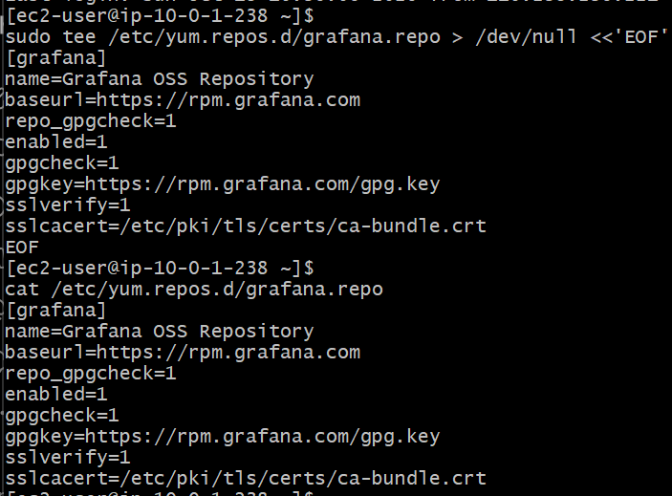
Step 2: Install Grafana
Now we'll install Grafana using dnf.
Run this command on your EC2 instance:
sudo dnf install -y grafana
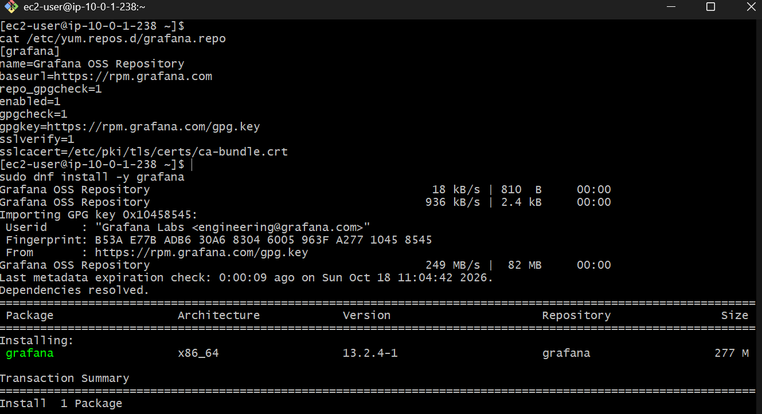
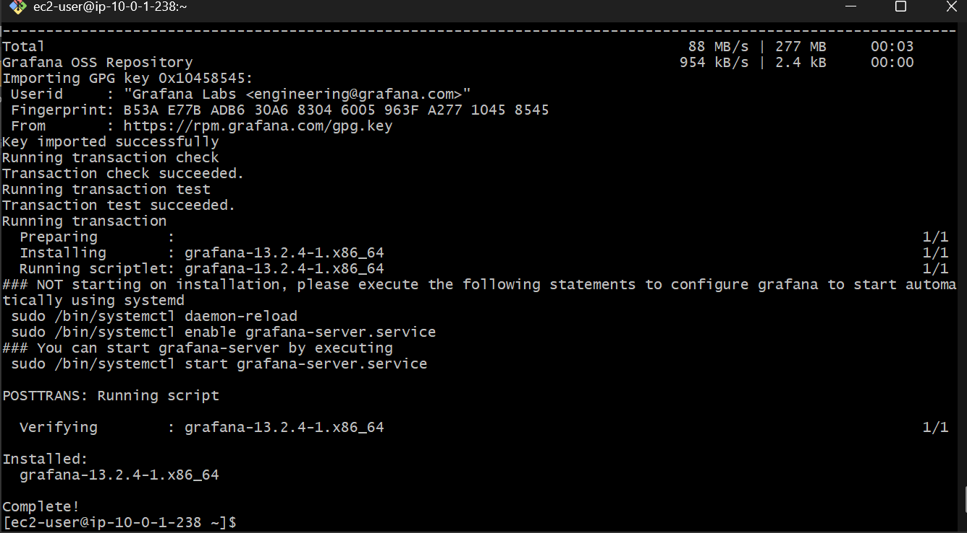
Step 3: Enable and start Grafana
Run these commands in your EC2 terminal, in order: sudo systemctl daemon-reload
sudo systemctl enable grafana-server
sudo systemctl start grafana-server
What these commands do:
- daemon-reload — refreshes systemd's service definitions.
- enable — configures Grafana to start automatically when the instance boots.
- start — starts Grafana now.
Verify Step 3
Run: sudo systemctl status grafana-server --no-pager
We want to see Active: active (running) and ideally enabled.
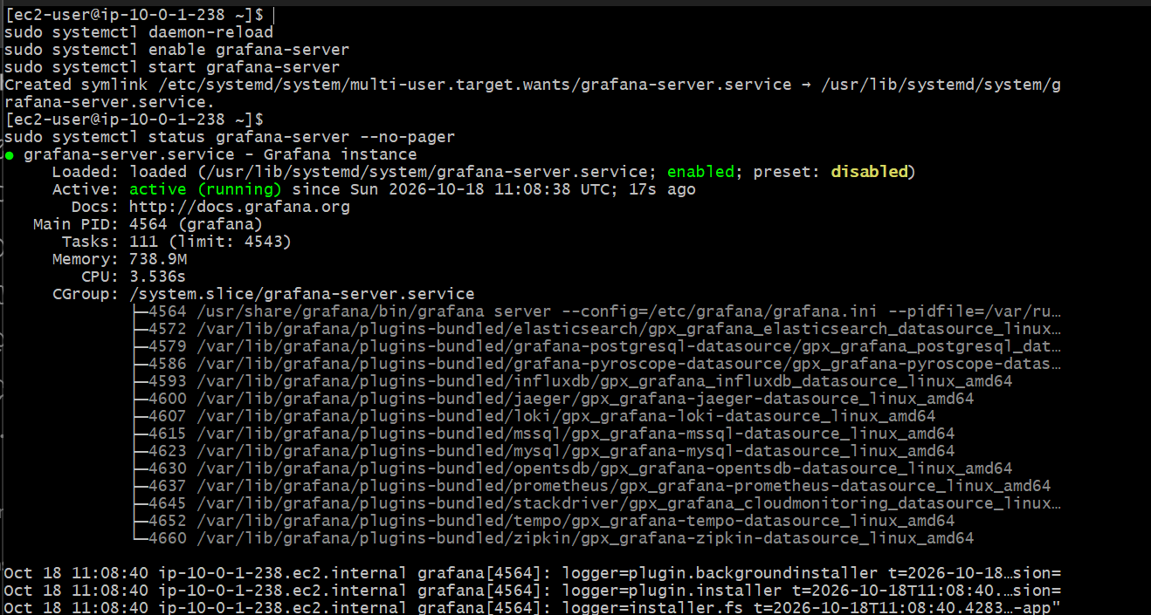
Step 4: Verify Grafana is listening on port 3000
Grafana's default web interface uses port 3000. Before opening the browser, let's confirm that the service is responding locally.
Run this command on your EC2 instance: curl -s -o /dev/null -w "HTTP Status: %{http_code}\n" http://127.0.0.1:3000/login
A response such as HTTP Status: 200 confirms that the login page is responding. A redirect status such as 302 can also be normal.
Then run: sudo ss -lntp | grep ':3000'
This second command shows the address on which Grafana is listening.
Important: Do not open port 3000 to the entire internet. We'll access Grafana securely through an SSH tunnel, just as we did with Prometheus
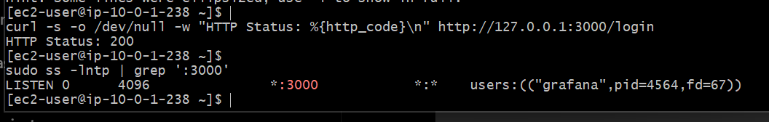
Step 5: Open Grafana securely in your browser
We'll use an SSH tunnel from your Windows computer, similar to the Prometheus connection.
5.1 Open Git Bash on Windows
Run this command, using the same key you used for Prometheus:
ssh -i ~/Downloads/jenkins.pem -N -L 3000:127.0.0.1:3000 ec2-user@98.82.23.41
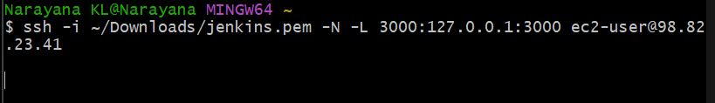
Important:
- If the EC2 public IP has changed since you restarted it, replace 98.82.23.41 with the current public IPv4 address from the EC2 Console.
- Keep this terminal open. A successful tunnel normally stays running without printing a new prompt.
- If Windows says port 3000 is already in use, tell me before trying another port.
5.2 Open Grafana
Open this address in your Windows browser:
http://localhost:3000/login
The Grafana login page should appear.
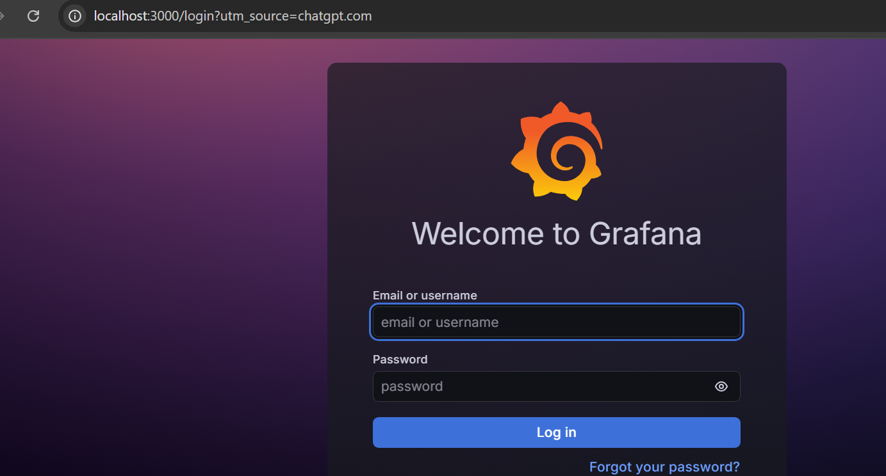
Step 6: Log in to Grafana
The default initial credentials for a fresh Grafana installation are:
- Username: admin
- Password: admin
- Enter admin as the username.
- Enter admin as the password.
- Click Log in.
- Grafana should prompt you to change the default password. Set a strong new password and store it securely.
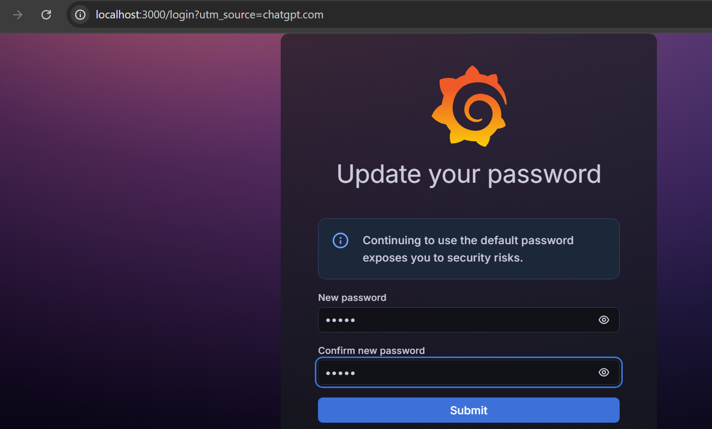
If you already changed the password, use your existing credentials instead.
Step 7: Add Prometheus as a data source
Now we'll connect Grafana to your existing Prometheus server.
Since Prometheus listens on 127.0.0.1:9090 on the EC2 instance, and Grafana is running on that same instance, we can use this URL directly.
7.1 Open data sources
In the Grafana web interface:
- Open the left navigation menu.
- Select Connections.
- Select Data sources.
- Click Add data source.
- Choose Prometheus.
The exact menu layout may vary slightly by Grafana version.
7.2 Configure the connection
Set the following field:
Name
Prometheus
Prometheus server URL
http://127.0.0.1:9090
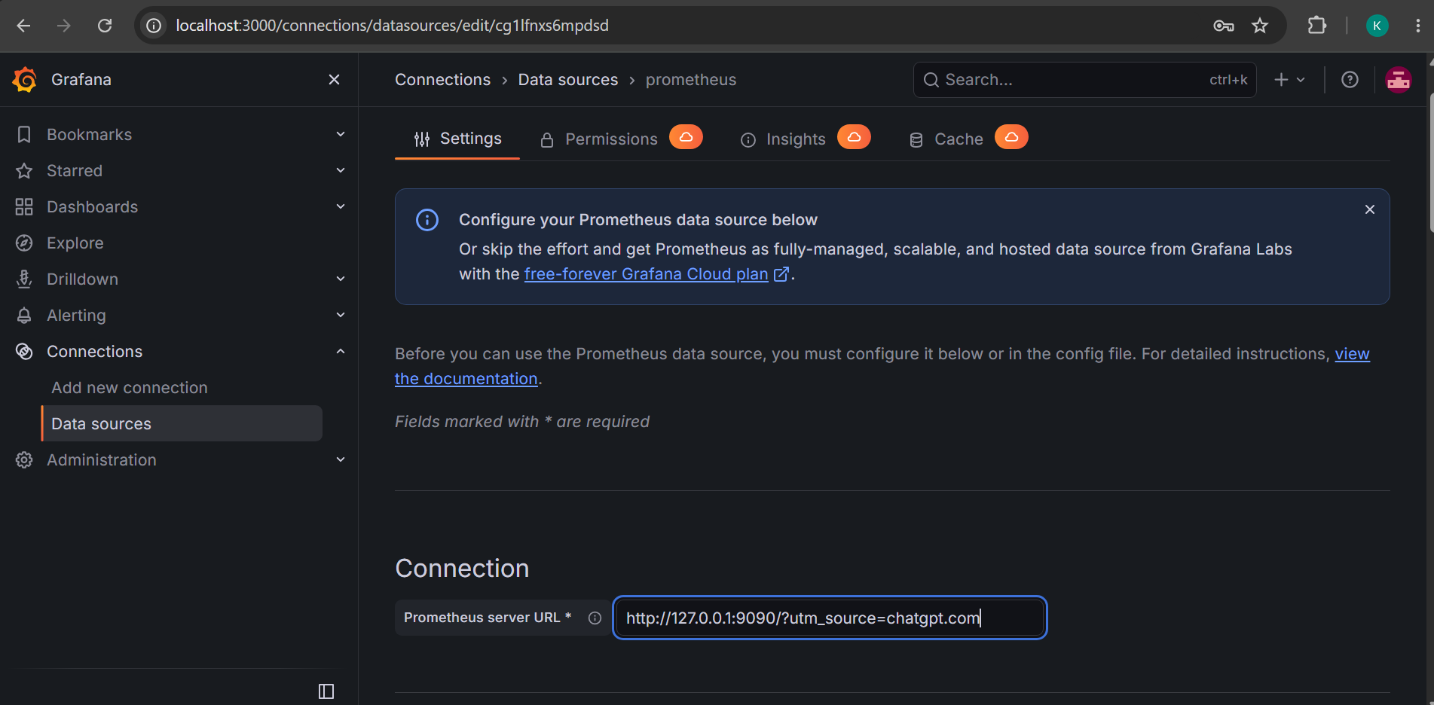
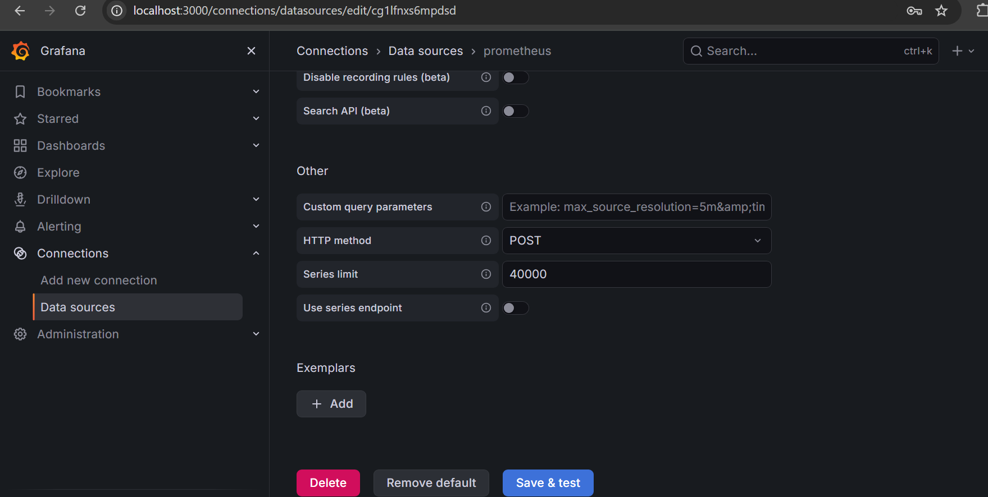
Leave the other settings at their defaults for now, then click Save & test.
7.3 Verify
We want Grafana to display a successful connection message, typically “Successfully queried the Prometheus API.”
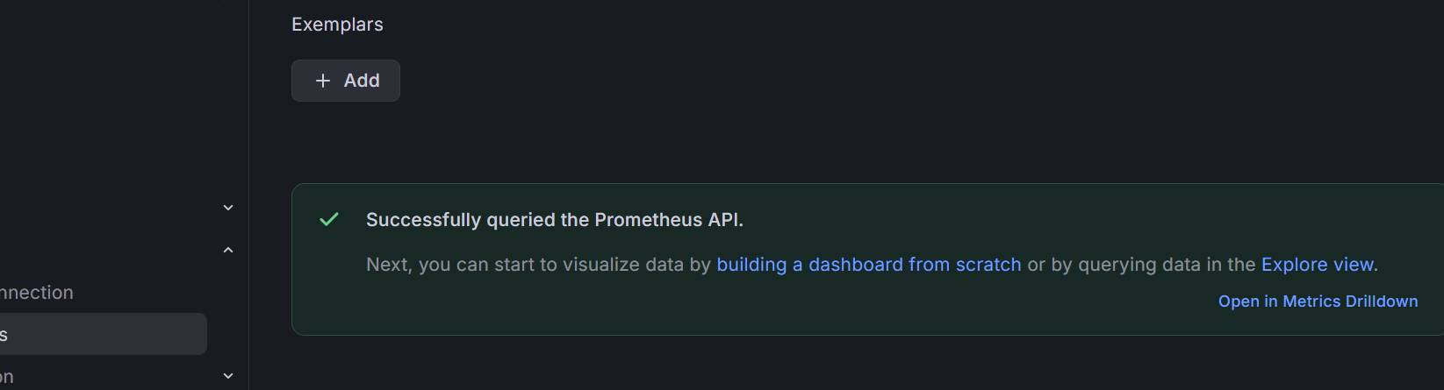
Step 8: Query metrics in Grafana Explore
Now let's verify that Grafana can retrieve actual system metrics from Prometheus.
- In Grafana, open Explore from the left navigation menu.
- Select the Prometheus data source.
- In the query editor, enter this metric:
up
4. Click Run query (or Run queries, depending on your interface).
Expected result
You should see values of 1 for healthy targets, including prometheus, node_exporter, and snmp_exporter.
The up metric returns 1 when a target scrape succeeds and 0 when it fails.
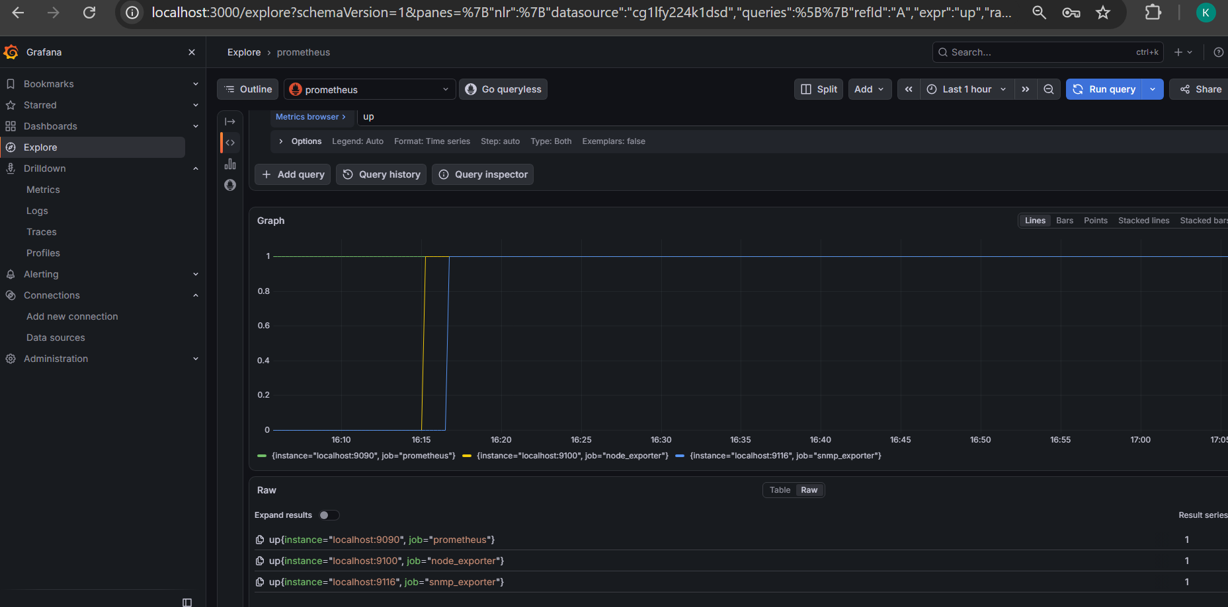
Task 7 — Dynamic Service Discovery
Step 1: Inspect the current Prometheus configuration
First, let's check the configuration before making any changes. We don't want to overwrite your working scrape jobs or alerting settings.
Run this command on your EC2 instance: sudo cat /etc/prometheus/prometheus.yml
Review the output. It should include your existing global, alerting, rule_files, and scrape_configs sections.
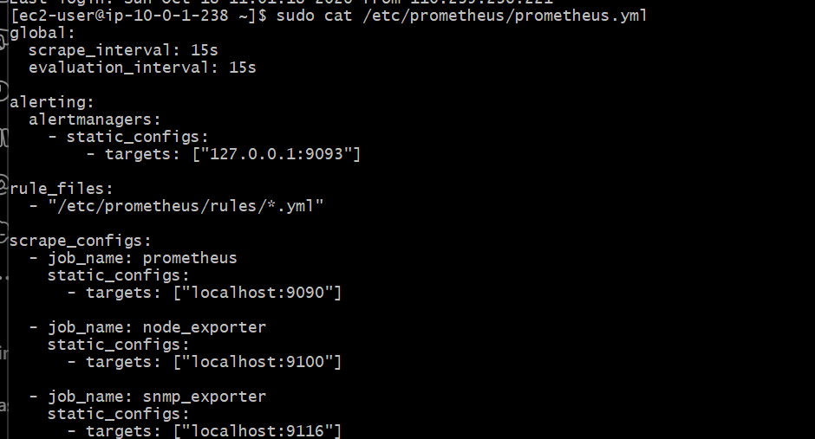
Step 2: Create a file-based service discovery target file
Prometheus supports file-based service discovery, which lets it read targets from a separate JSON or YAML file and detect changes without requiring a Prometheus restart.
We'll create a dedicated target file for Node Exporter. First, create a directory for the discovery files:
sudo mkdir -p /etc/prometheus/file_sd
sudo chown prometheus:prometheus /etc/prometheus/file_sd
sudo chmod 755 /etc/prometheus/file_sd
Verify Step 2
Run:ls -ld /etc/prometheus/file_sd
Expected output should show the directory exists and is accessible, ideally owned by prometheus prometheus.
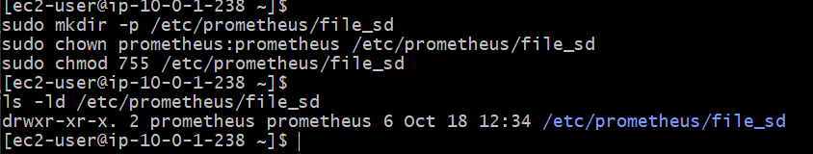
Step 3: Create the dynamic target file
We'll define Node Exporter in a separate JSON file. Prometheus will discover the target from this file rather than from a hard-coded static_configs list in the main configuration.
Run: sudo tee /etc/prometheus/file_sd/node-exporter.json > /dev/null <<'EOF'
[
{ "targets": ["localhost:9100"],
"labels": { "job": "node_exporter_dynamic",
"environment": "lab"
}
}
]
EOF
Verify the file
Run: sudo cat /etc/prometheus/file_sd/node-exporter.json
sudo -u prometheus test -r /etc/prometheus/file_sd/node-exporter.json && echo "Prometheus can read the discovery file"
Expected: the JSON appears correctly, followed by:
Prometheus can read the discovery file
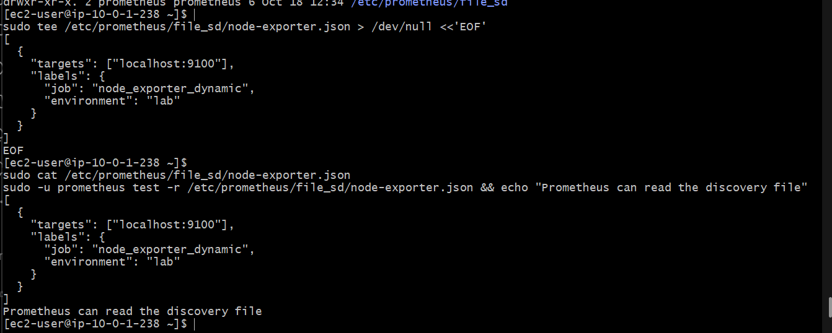
Step 4: Configure Prometheus file-based discovery
Now we'll add a new scrape job to /etc/prometheus/prometheus.yml. We'll preserve your existing three jobs, Alertmanager configuration, and disk alert rules.
Open the configuration file:
sudo vi /etc/prometheus/prometheus.yml
Add the following job under the existing scrape_configs list, at the same indentation level as prometheus, node_exporter, and snmp_exporter:
- job_name: node_exporter_file_sd
file_sd_configs:
- files:
- "/etc/prometheus/file_sd/node-exporter.json"
refresh_interval: 30s
Save the file in vi
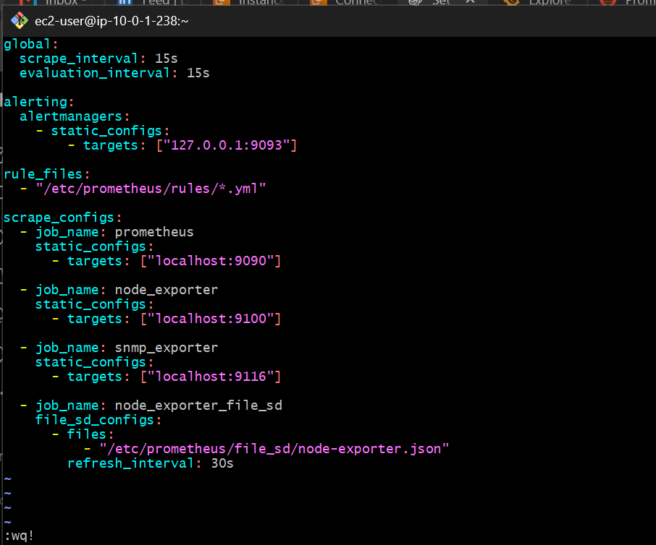
Verify the configuration
Run: sudo promtool check config /etc/prometheus/prometheus.yml
Expected result:
SUCCESS: ... is valid prometheus config file syntax
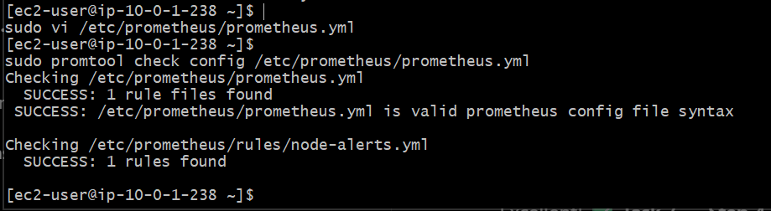
Step 5: Restart Prometheus
Run these commands on your EC2 instance:
sudo systemctl restart prometheus
sudo systemctl is-active prometheus
Expected output: active
Now verify that Prometheus is ready:
curl -s http://127.0.0.1:9090/-/ready
Expected output: Prometheus Server is Ready.
This applies the new configuration while preserving your existing monitoring jobs.
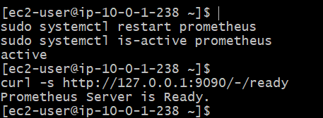
Step 6: Verify the dynamically discovered target
Now we'll check whether Prometheus has discovered the new Node Exporter target from the JSON file and is scraping it successfully.
Run this command:

curl -s http://127.0.0.1:9090/api/v1/targets | python3 -c 'import json,sys; d=json.load(sys.stdin); [print("Job:",t["labels"].get("job"),"| Instance:",t["labels"].get("instance"),"| Health:",t["health"],"| Environment:",t["labels"].get("environment","N/A"),"| Error:",t.get("lastError","") or "None") for t in d["data"]["activeTargets"]]'
Expected result
You should see four jobs:
- prometheus — UP
- node_exporter — UP
- snmp_exporter — UP
- node_exporter_file_sd — UP, with environment=lab
The dynamically discovered target should have instance localhost:9100. The original static Node Exporter target should remain healthy too.
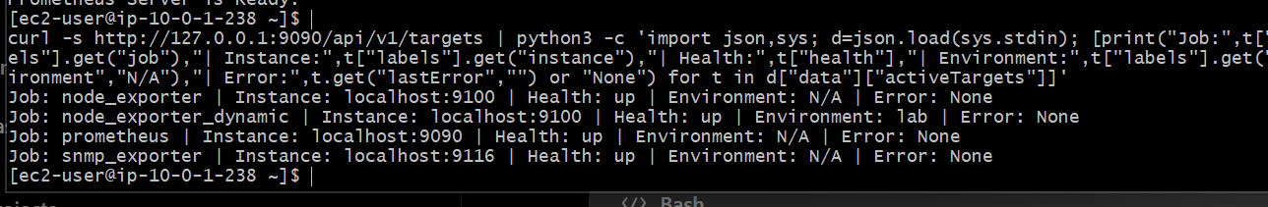
Step 7: Verify automatic discovery refresh
Now we'll test the key benefit of file-based discovery: Prometheus can detect target-file changes without restarting its service.
We'll safely change the discovery target's label from environment: lab to environment: production-demo. This is only a demonstration label; it does not change the actual EC2 environment.
Run this command:
sudo sed -i 's/"environment": "lab"/"environment": "production-demo"/' /etc/prometheus/file_sd/node-exporter.json
Verify the file contents: sudo cat /etc/prometheus/file_sd/node-exporter.json
Expected label: "environment": "production-demo"

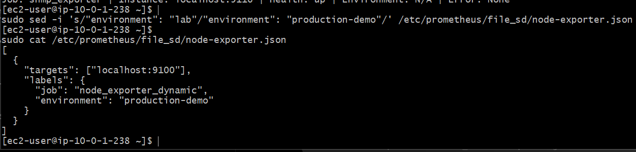
Step 8: Verify automatic refresh
Now wait 30–45 seconds to allow Prometheus to reload the file. Do not restart the service.
Then run: curl -s http://127.0.0.1:9090/api/v1/targets | python3 -c 'import json,sys; d=json.load(sys.stdin); [print("Job:",t["labels"].get("job"),"| Environment:",t["labels"].get("environment","N/A"),"| Health:",t["health"],"| Error:",t.get("lastError","") or "None") for t in d["data"]["activeTargets"] if t["labels"].get("job")=="node_exporter_dynamic"]'
Expected result
You should see the dynamic job with:
- Environment: production-demo
- Health: up
- Error: None
This verifies that Prometheus detected the JSON file change automatically without a restart.
Step 9: Verify dynamic discovery in the Prometheus UI
1. Open Prometheus in your browser
Keep your existing SSH tunnels running if they are still open. If the Prometheus tunnel is not running, open a new Git Bash window on Windows and run:
ssh -i ~/Downloads/jenkins.pem -N -L 9090:127.0.0.1:9090 ec2-user@98.82.23.41
If your EC2 public IP has changed, replace 98.82.23.41 with its current public IPv4 address.
Open: Open Prometheus Targets UI
2. Check the Targets page
On the Targets page:
- Find the node_exporter_dynamic job.
- Confirm its endpoint is localhost:9100.
- Confirm its state is UP.
- Expand the target details if needed and check the labels.
You should also see your original prometheus, node_exporter, and snmp_exporter jobs.
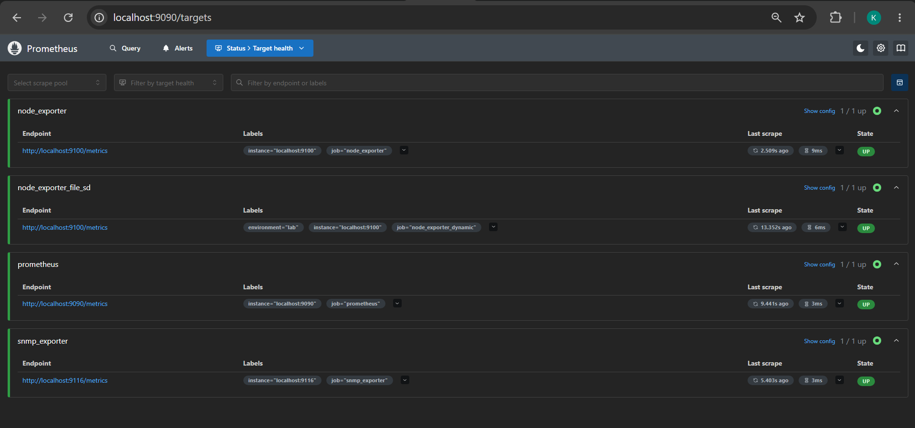
3. Verify the updated label in the UI
Open the Prometheus expression browser:
Open Prometheus Expression Browser
In the expression field, enter:
up{job="node_exporter_dynamic"}
Click Execute. The result should be 1.
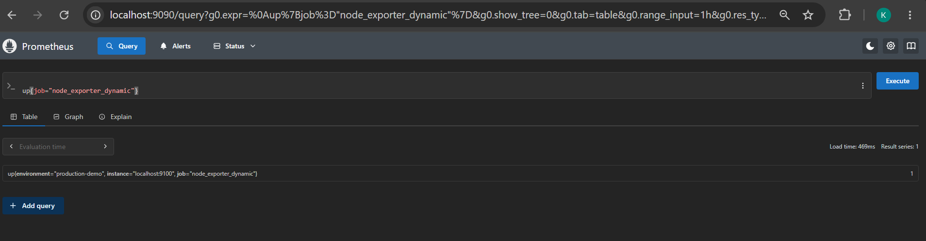
Then try this query: node_uname_info{job="node_exporter_dynamic", environment="production-demo"}
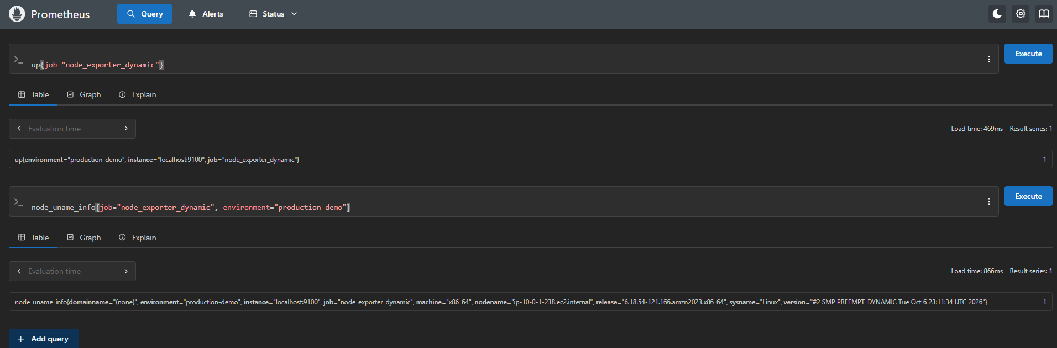
Task 8 — Disk-Space Alert Rules
We already configured the NodeDiskSpaceLow alert rule earlier. Now we'll document and verify it in the correct task order, using both CLI and UI checks.
Step 1: Verify the alert rule from the EC2 terminal
Connect to your EC2 instance through SSH and run:
sudo cat /etc/prometheus/rules/node-alerts.yml
Then validate the rule:
sudo promtool check rules /etc/prometheus/rules/node-alerts.yml
Expected result:
Checking /etc/prometheus/rules/node-alerts.yml
SUCCESS: 1 rules found
The rule should alert when the root XFS filesystem has less than 15% space available, continuously for five minutes.
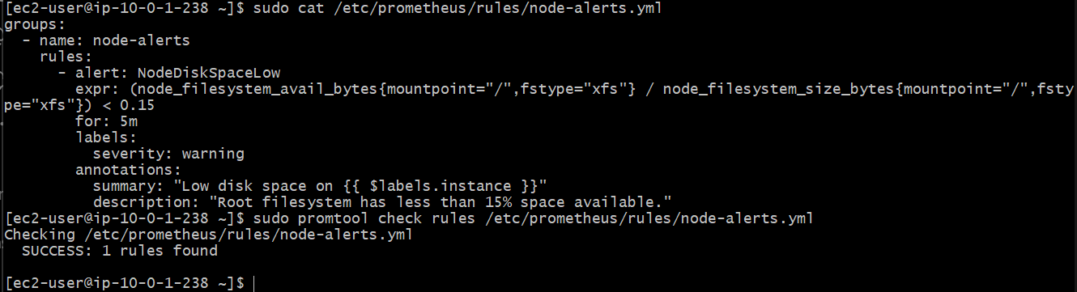
Step 2: Verify the alert in Prometheus UI
- Open http://localhost:9090/alerts in your browser. Ensure your Prometheus SSH tunnel is running.
- Find the NodeDiskSpaceLow alert.
- Check its current state. Since your disk has plenty of free space, it should normally be Inactive.
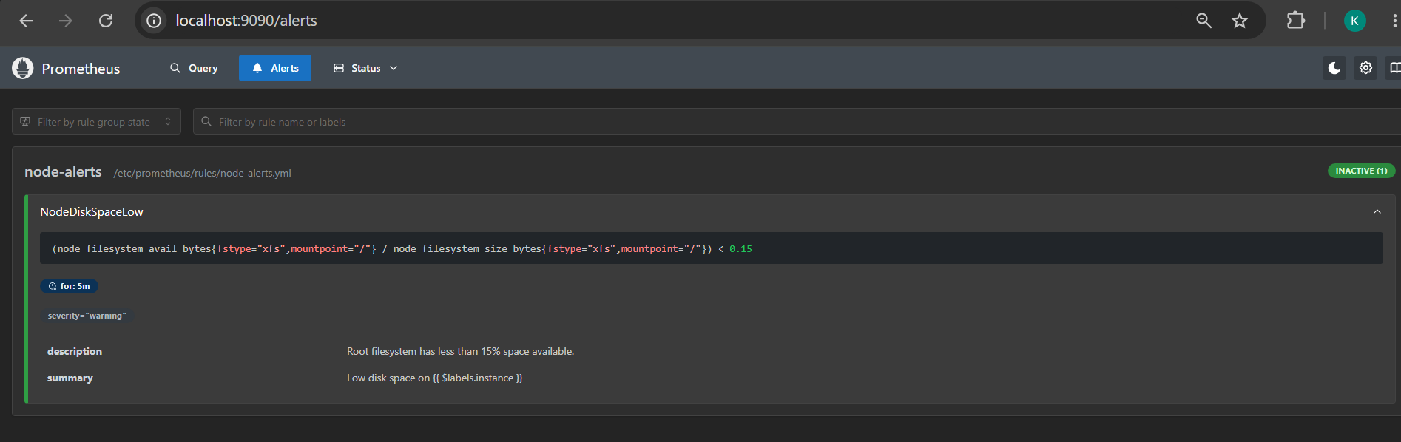
Step 3: Verify Alertmanager in the UI
Next, let's check whether Prometheus is connected to Alertmanager.
- Open the Prometheus UI.
- Navigate to Status → Runtime & Build Information only if needed; instead, first open the Alertmanager UI through your SSH tunnel.
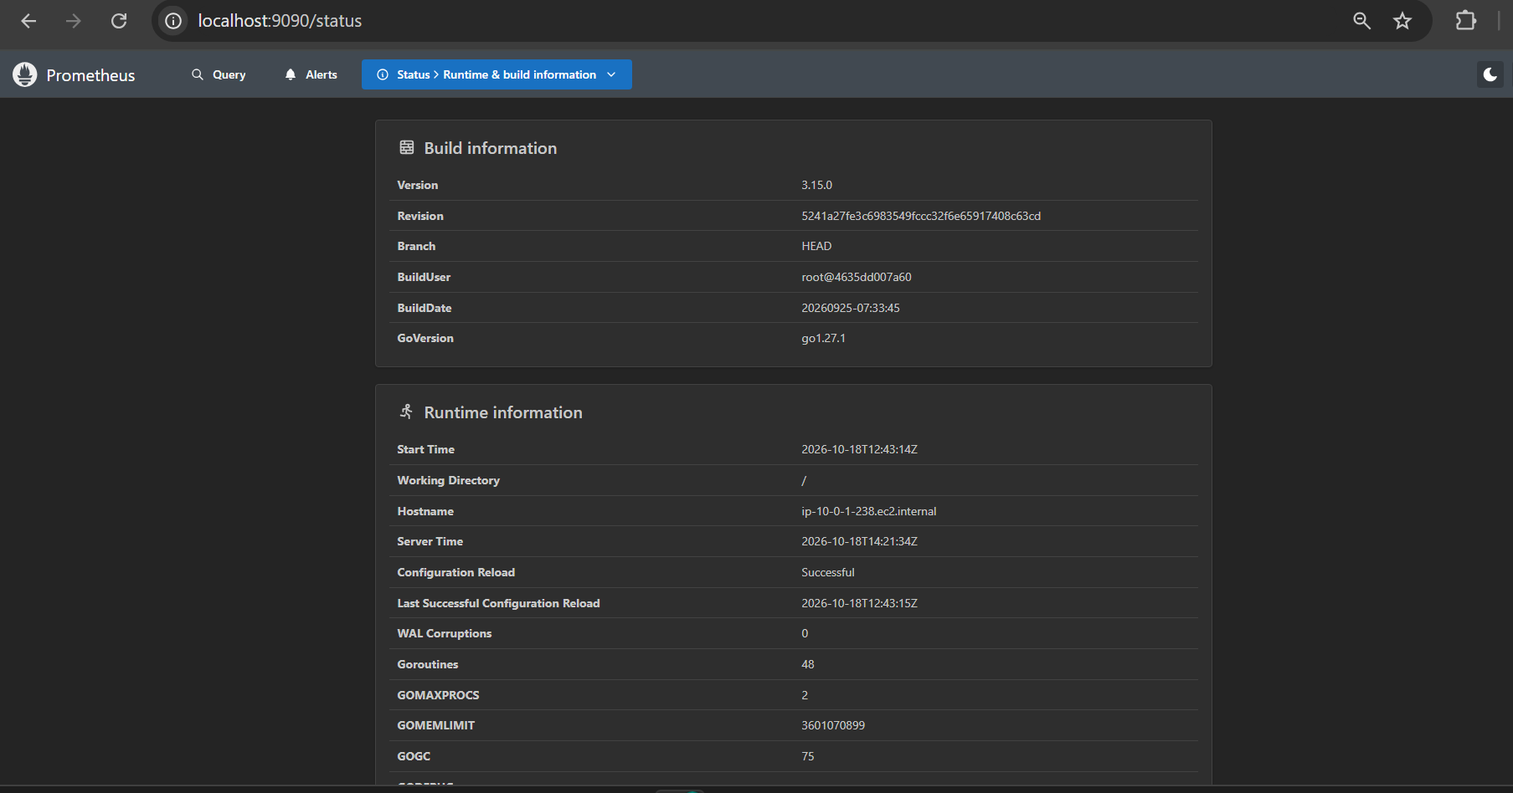
In a new Git Bash terminal on your Windows machine, run:
ssh -i ~/Downloads/jenkins.pem -N -L 9093:127.0.0.1:9093 ec2-user@98.82.23.41
Keep that terminal open, then visit:
http://localhost:9093
You should see the Alertmanager interface. Check whether any alerts are currently listed; an empty list is normal when no alert is firing.
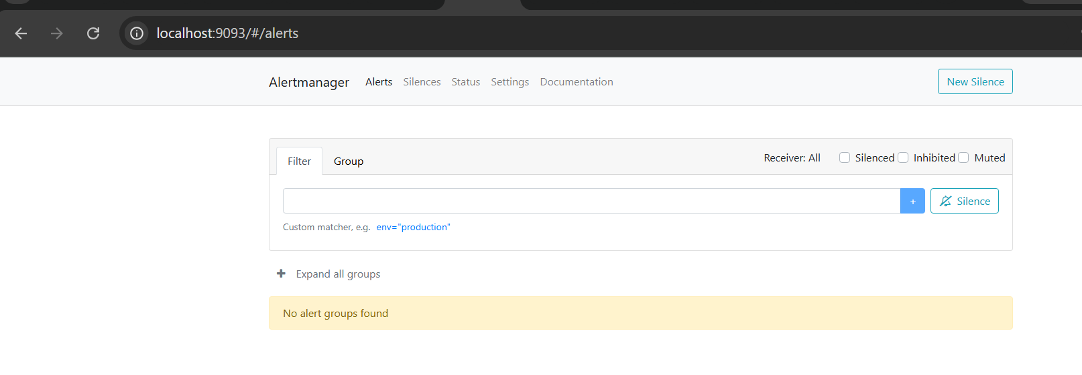
Step 4: Verify Prometheus-to-Alertmanager connectivity
Return to your EC2 SSH terminal and run:
curl -s http://127.0.0.1:9090/api/v1/alertmanagers | python3 -m json.tool
Look for an activeAlertmanagers entry containing an http://127.0.0.1:9093/api/v2/alerts URL.
Also verify Alertmanager's health:
curl -s http://127.0.0.1:9093/-/healthy
Expected output:
Alertmanager is Healthy.
Disk-Space Alert Rules is complete.
Your CLI verification confirms both services are working correctly:
- Prometheus → Alertmanager: Connected to http://127.0.0.1:9093/api/v2/alerts.
- Dropped Alertmanagers: [] — none dropped.
- Alertmanager health: OK.
- Alert rule: NodeDiskSpaceLow is valid and currently inactive because the disk-space threshold is not breached.
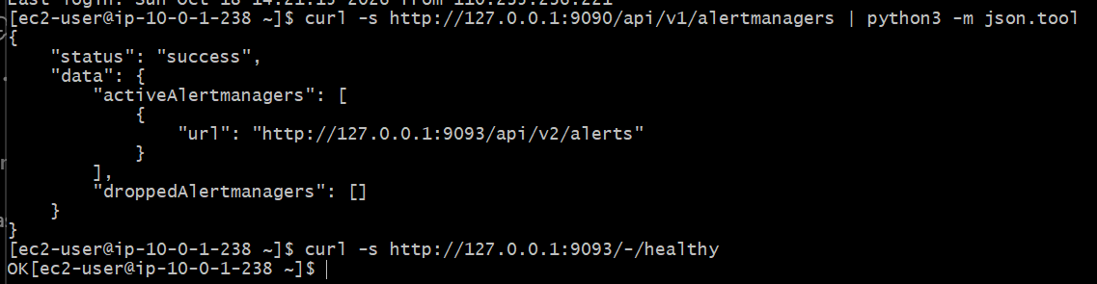
Task 9 — Build a Custom Grafana Dashboard
We'll create a dashboard using the Grafana UI and verify each panel as we go. We'll start with CPU utilization, then add memory, disk, load, uptime, and target health.
Step 1: Open Grafana
- Ensure your Grafana SSH tunnel is running. If it isn't, open a new Git Bash terminal on Windows and run:
ssh -i ~/Downloads/jenkins.pem -N -L 3000:127.0.0.1:3000 ec2-user@98.82.23.41
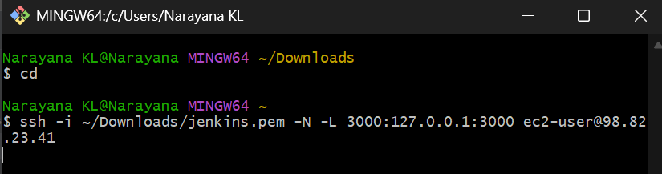
- Keep the terminal open and visit http://localhost:3000.
- Sign in with your Grafana admin credentials.
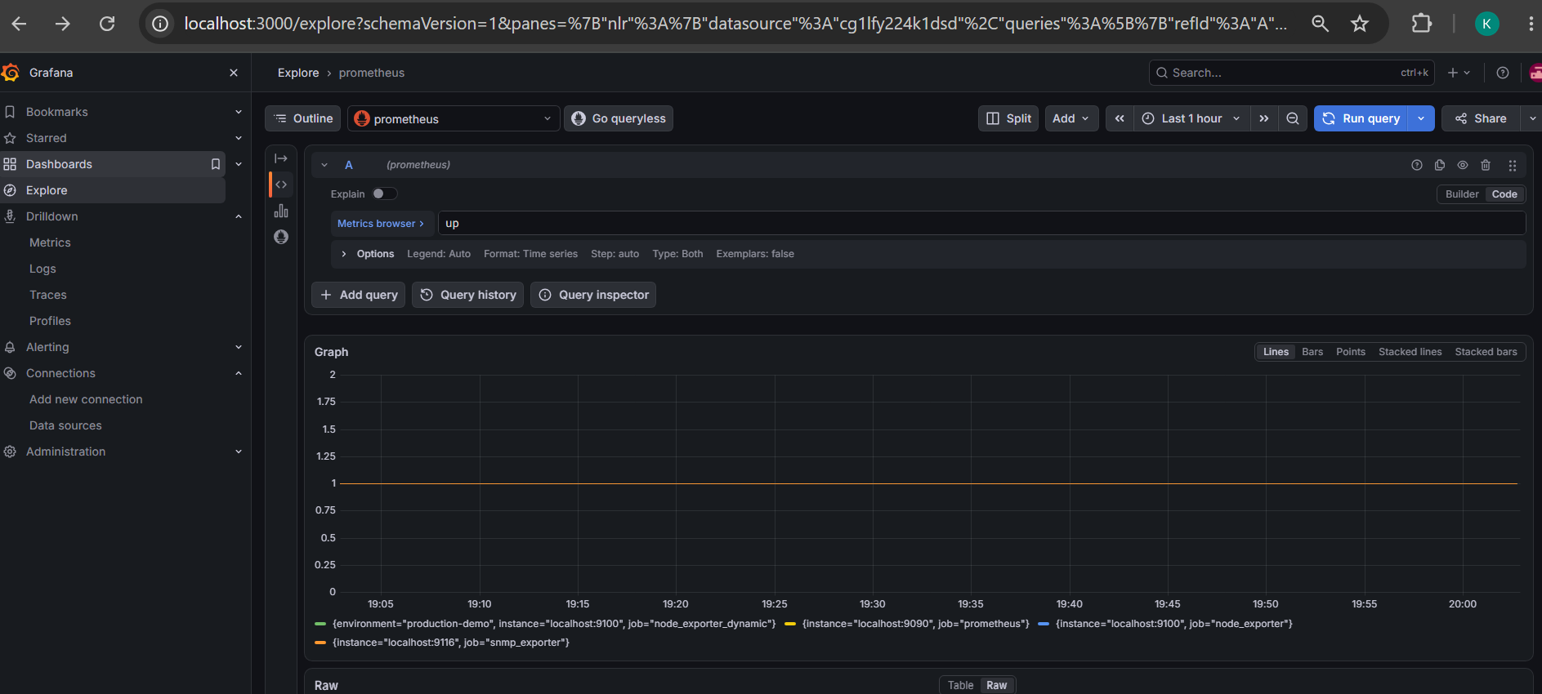
- In the Grafana sidebar, open Dashboards and select New → New dashboard. The exact menu wording may vary slightly by Grafana version.
- Select Add visualization and choose your existing Prometheus data source.
You should now see the panel editor with a query area.
Step 2: Add the CPU Utilization panel
- Click Add → Visualization (or click the panel-add option if it appears under the Add menu).
- Select your existing Prometheus data source.
- In the panel editor, locate the query editor and switch to Code mode if needed.
- Enter this PromQL query:
100 * (1 - avg by(instance) (rate(node_cpu_seconds_total{mode="idle",job="node_exporter"}[5m])))
This calculates CPU utilization as a percentage across the CPU cores reported by Node Exporter.
- Click Run queries or Refresh if required.
- Set the visualization type to Time series. If you prefer a current-value display, you can choose Gauge instead.
- Set the panel title to CPU Utilization (%).
You should see a numeric percentage or a time-series line. The value may be low while the EC2 instance is idle.
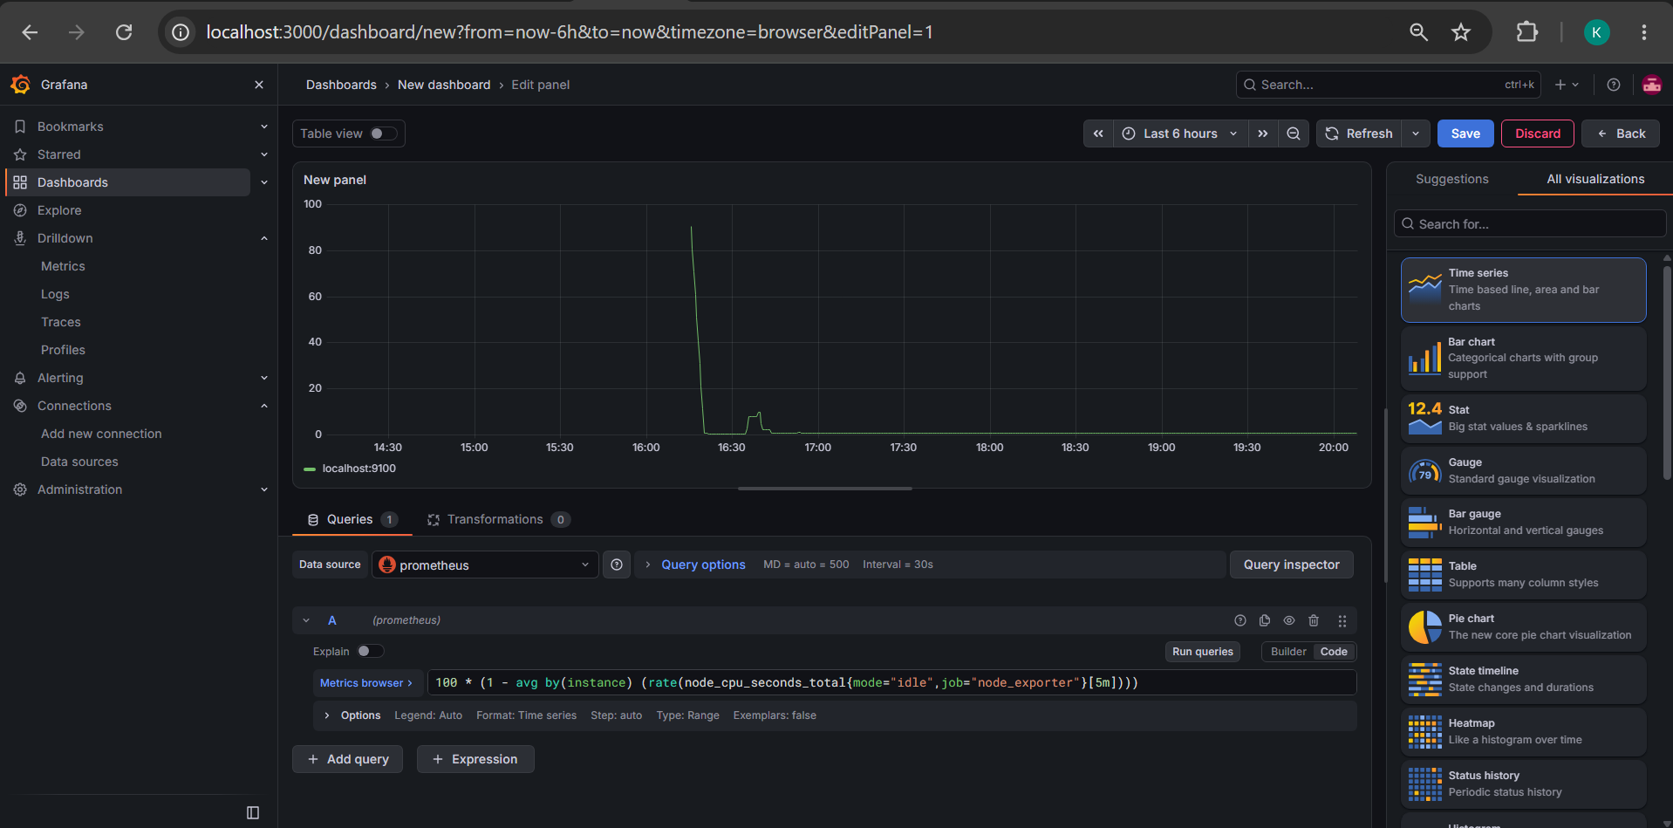
Verify CPU utilization
Verify CPU utilization
- Click Run queries.
- Check the graph area for a time-series line.
- Under All visualizations, select Gauge if you want a clear current CPU utilization percentage. (You can keep Time series if you prefer the historical trend.)
- Find the panel title setting—usually in the panel options on the right—and change New panel to CPU Utilization (%).
- Click Back to return to the dashboard, then click Save and give the dashboard the name EC2 Monitoring Dashboard.
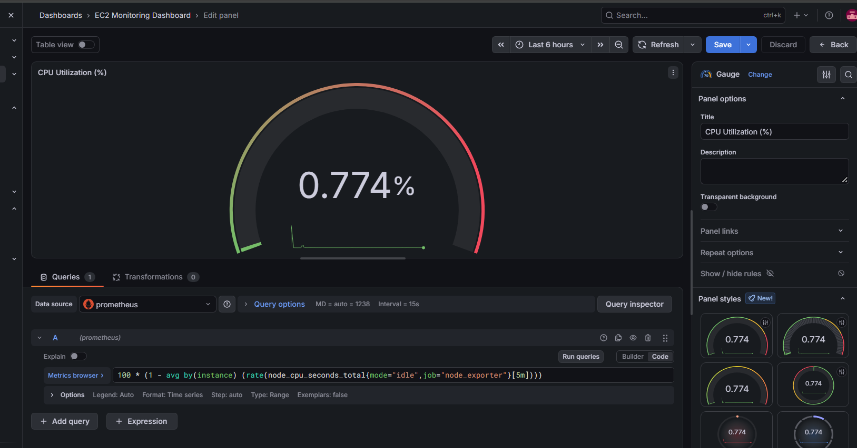
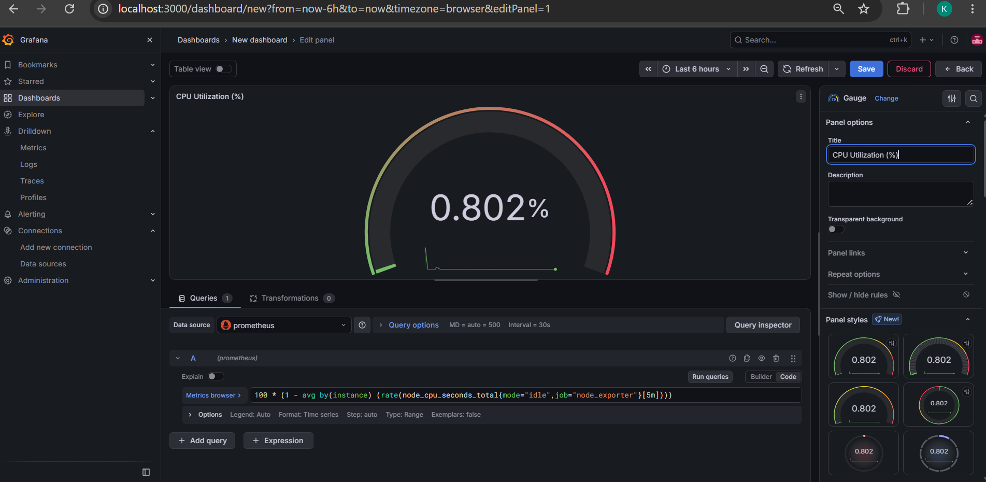
Step 3: Add Memory Utilization (%)
We'll add a second panel to monitor how much memory your EC2 instance is using.
- Open your saved EC2 Monitoring Dashboard.
- Click Add → Visualization.
- Select the existing Prometheus data source.
- In the query editor, switch to Code mode if necessary and enter:
100 * (1 - node_memory_MemAvailable_bytes{job="node_exporter"} / node_memory_MemTotal_bytes{job="node_exporter"})
- Click Run queries. You should see a percentage value or graph.
- Select Gauge under visualizations.
- Under Panel options → Title, enter Memory Utilization (%).
- Under Standard options, set:
  - Unit: Percent (0–100)
  - Min: 0
  - Max: 100
This query measures memory in use based on the memory available to Linux, rather than treating all unused memory as unavailable.

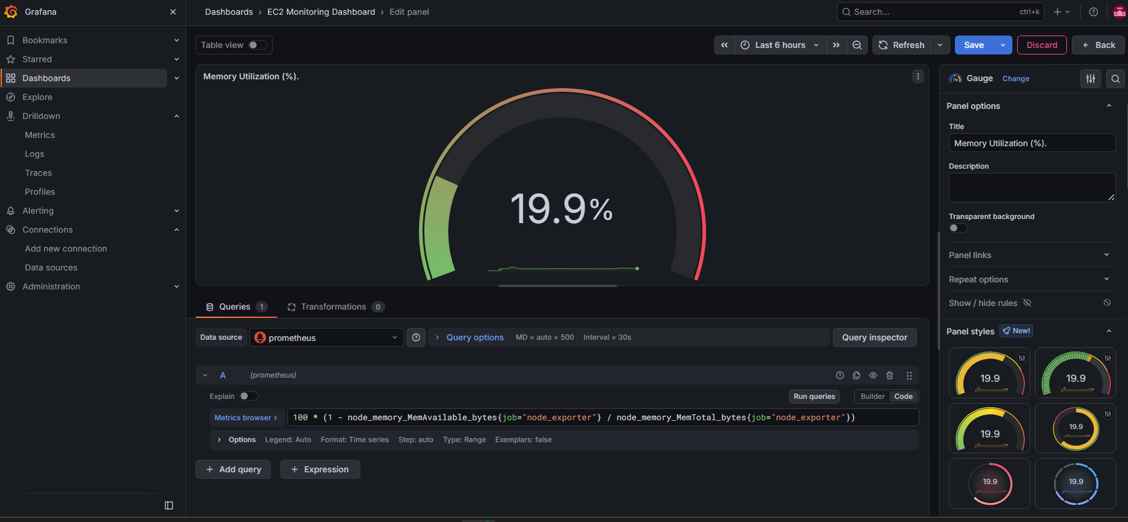
Step 4: Add Disk Utilization (%)
We'll monitor the percentage of your EC2 root filesystem that is used.
- Open EC2 Monitoring Dashboard.
- Click Add → Visualization.
- Select the Prometheus data source.
- Enter this query in the query editor using Code mode:
100 * (1 - node_filesystem_avail_bytes{job="node_exporter",mountpoint="/",fstype="xfs"} / node_filesystem_size_bytes{job="node_exporter",mountpoint="/",fstype="xfs"})
- Click Run queries.
- Select Gauge as the visualization.
- Under Panel options → Title, enter Disk Utilization (%).
- Under Standard options, set:
  - Unit: Percent (0–100)
  - Min: 0
  - Max: 100
This query calculates the percentage of space used on the root XFS filesystem. Your value should be below 100%; the exact percentage depends on current disk usage.
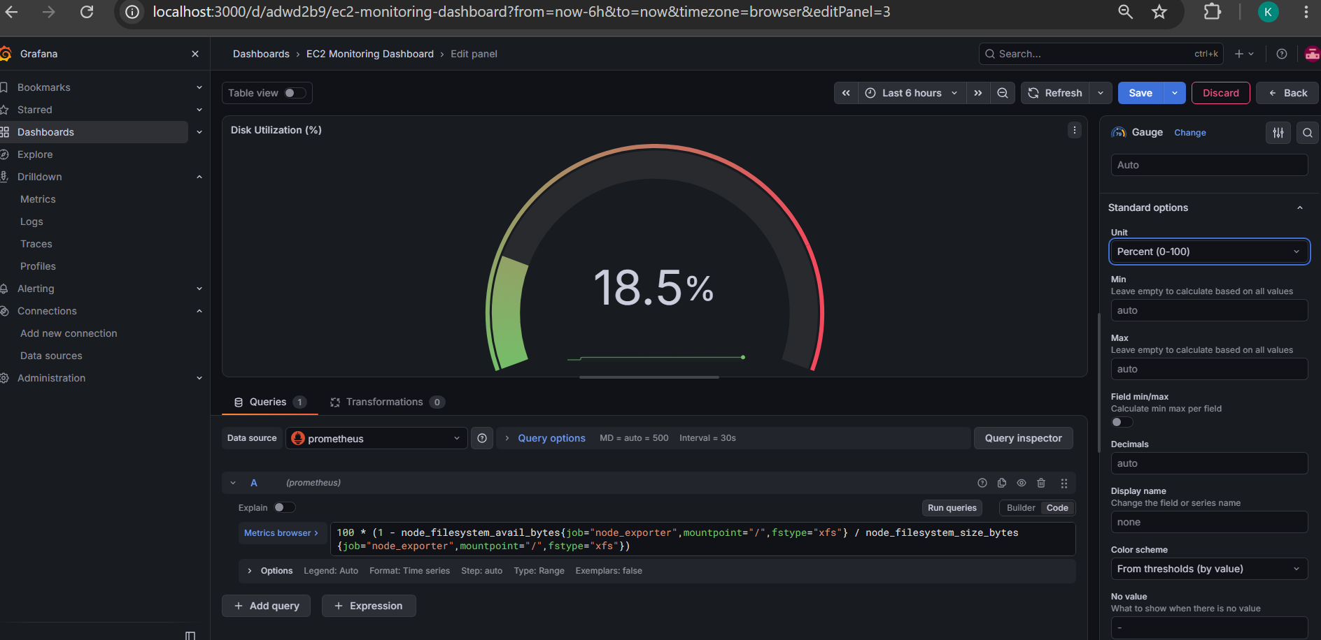
Step 5: Add the System Load panel
This panel will show the Linux system load average over the last minute.
Follow these steps
- Open EC2 Monitoring Dashboard.
- Click Add → Visualization.
- Select the Prometheus data source.
- In the query editor, enter:
node_load1{job="node_exporter"}
- Click Run queries.
- Select Stat under visualizations.
- Under Panel options → Title, enter System Load (1 min).
- Under Standard options → Unit, keep the default numeric unit (no percentage).
The value represents the average system load over one minute, not a percentage. On a lightly loaded instance, it may be a small number.
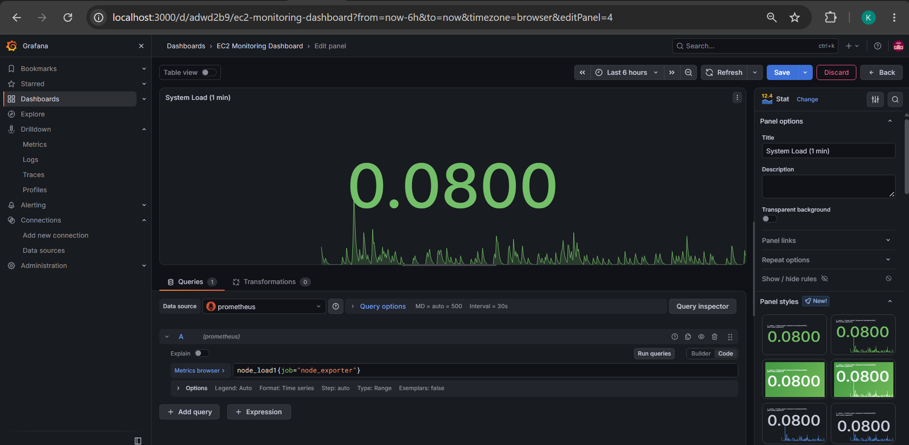
Step 6: Add the EC2 Uptime panel
This panel will show how long the Linux system has been running since its last boot.
- Open EC2 Monitoring Dashboard.
- Click Add → Visualization.
- Select your Prometheus data source.
- Enter this PromQL query:
node_time_seconds{job="node_exporter"} - node_boot_time_seconds{job="node_exporter"}
- Click Run queries.
- Select Stat as the visualization.
- Under Panel options → Title, enter EC2 Uptime.
- Under Standard options → Unit, choose Time → Duration (seconds) if available. This displays uptime as a duration rather than a raw number.
Finish the uptime panel
- Under All visualizations, select Stat.
- Confirm the title remains EC2 Uptime.
- Keep the unit as duration (s) and the calculation as Last.
- Verify that the Stat panel displays the uptime duration.
